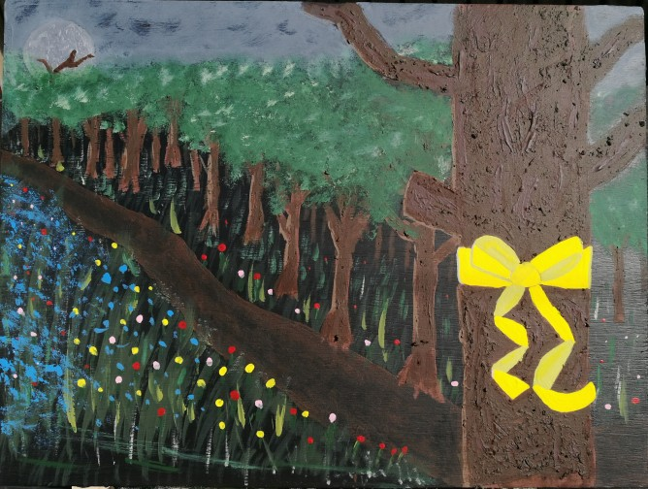
‘Tie a Yellow Ribbon’ by Mark Cridland
Some of you will now be humming or singing the song, ‘Tie a Yellow Ribbon’ first released in 1973. I remember my Gran singing along to the Brotherhood of Man version.
I noticed on Facebook that the congregation of Dalziel St Andrews in Motherwell have been encouraged to tie a coloured ribbon to the railings of their church and offer a prayer. Other churches and groups are also doing similar things.
I would like to encourage the church family and community around Kay Park to do the same and tie a piece of coloured ribbon to the railings at the front of our building, of course only if it is safe to do so and part of your daily routine takes you in that direction. If you are unable to get to the church to do this why not tie a piece of ribbon to your own front door handle or to a tree or plant in your garden, and again offer a prayer.
We are unable to be together in the one place but may this simple act be…
a sign of the common humanity we share
a sign of trust in the God who always welcomes us
a sign of hope that one day we will welcome one another again
warmest good wishes, Rev Fiona.

