The vision of the Church of Scotland is to be a church which seeks to inspire the people of Scotland and beyond with the Good News of Jesus Christ through enthusiastic, worshipping, witnessing, nurturing and serving communities.

Entry of the Bible
(we stand as the Bible is brought into church)
Introit

Grace & Call to Worship

Praise 279 Make Way, Make Way,

Prayer of Approach and Lord’s Prayer

Palm Sunday Praise!

Praise MP 242 Hosanna, Hosanna,

Bible reading Mark chapter 11 v 1 – 11 (pg 1015)
(Jeff Davies)

Praise 374 From Heaven you came

REFLECTION ON GOD’S WORD
Anthem

Prayers of Thanksgiving and for others

Praise 367 Hosanna, Loud Hosanna

Benediction

Notices

A warm welcome is extended to everyone this morning and especially to any visitors worshipping with us today.

Please take a few minutes to read the screens as there may be information, which was received too late for the printed intimations.

Our minister, the Rev. Fiona Maxwell, can be contacted by telephone on 01563 521762, by mobile on 07507 312123 or by email, FMaxwell@churchofscotland.org.uk

The email address for the Church Administrator is kppcchurchoffice@gmail.com or phone 07394 173977. Please note the new email address for the church administrator.

If you are watching the service via live stream the digital order of service is available on the church website under the services page.

Tea/coffee will be served after morning worship, please come down to the hall for a warm cuppa and even warmer chat and fellowship.

The video recording of Fiona Kendall's visit to the Friendship club is now available on the church website under World Mission Page. It's also available on the Facebook page. This is only available till 1 April.

Jean Deans would like to say a big thank you to all those who provided baking and help at the Faith Stories.

Easter Sunday The flower committee would like to ask you to bring a flower/flowers to help decorate our Easter Cross on Sunday 31 March. Thank you.

Wednesday Walkers meet at the Kay Park at 10am at the top car park near the Burns Centre, enjoy a walk round the park and a good chat and then have coffee/tea in the church café. All welcome.

Wednesday café is open every Wednesday morning from 10am – 12 noon. Please tell your friends and neighbours and come and enjoy the company and chat.

Maundy Thursday Communion 28 March at 7.30pm in the church.

The Fellowship of Kilmarnock Churches’ Good Friday Walk of Witness will take place on Friday 29th March. Please note a change of time to ensure we finish at The Cross just prior to the Good Friday Vigil, 12 noon at New Laigh Kirk. Gather from 10.30am outside the Salvation Army in Sturrock Street, as we aim to begin the Walk of Witness at 10.45am sharp.

Easter Trail Saturday 30 March from 1pm – 4pm, free family fun, Follow the trail around the Kilmarnock Centre Churches, try an activity at each one, complete all 7 activities to win a PRIZE. Kay Park Church are taking part in this event and the café area will be open to welcome all families.

Easter Sunday early morning service at 7.30pm in Kay Park followed by breakfast at Kay Park Church Hall. All welcome

24/7 PRAYER ROOM The Howard Centre will host a 24/7 Prayer Room throughout the first week of the school Easter holidays: Monday 1st – Sunday 7th April. Pray-in-person & pray-at-home slots are available. Please contact Elaine Wardrop at ewardrop@churchofscotland.org.uk to book a slot.

The Guild AGM is on Tuesday 2 April in the café area, please enter by the front door if possible.

Kirk Session Wednesday 3 April at 7pm in the church hall.

Guild Concert on Friday 12 April at 7pm Songs for All – Jill Clancy. Tickets £5 available from Guild members.

New Laigh Kirk presents Alastair McDonald Saturday 20 April at 2pm in New Laigh Kirk. Free entry, donations welcome.

Foodbank- Items can still be left at the back of the church in the wicker basket, these items are then taken to the Salvation Army for their foodbank, supplies are required urgently, so please give generously.

New to Kay Park?
If you are new to Kay Park, please feel free to approach the Minister, Rev Fiona on (01536) 521762 or the Session Clerk, Janette Steven, (01563) 401209, for further information about the Church and Membership. If you would like information about giving to the church financially, please contact the Treasurer, Alex Steven on 01563 401209
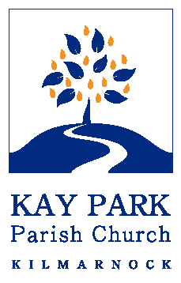
www.kayparkparishchurch.org.uk
(Registered Scottish Charity: SC008154)

PALM SUNDAY

Sunday 24 March 2024
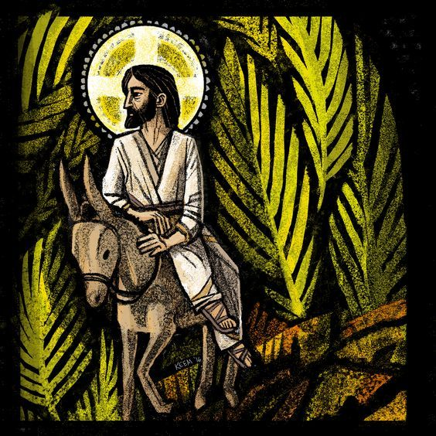
Minister
Rev. Fiona Maxwell

Organist
Mr Alex Ferguson

