Easter Sunday 2020

An Easter Day word from the Rev Fiona Maxwell

‘The Grace of the Lord Jesus Christ be with you all’

As many of you will be aware, I am currently on extended compassionate leave after the death of my Dad four weeks ago. Dad’s funeral was attended by a very limited number at the Crematorium and we were unable to have a Thanksgiving Service. This, of course, the experience for so many in these changed times.
I take this opportunity to ‘thank you’ for your kind words in cards, your thoughts and prayers for me and my family which have been a source of comfort.
In many and varied ways all our lives have been changed not just for now but perhaps for ever. I wonder what thoughts, questions, doubts, fears, hopes and dreams have been going through your minds in these days? There are no easy answers. No glib statements that can make everything ok. We need to acknowledge the sadness we feel. So many kinds of grief afflict us, as we think of the losses of this time, not only those associated with bereavement but everything else we have ’lost’ in these days. We need to be gentle with ourselves and one another, now and in the days to come when we emerge from isolation back into community.
On this Easter Sunday, so different as we find ourselves apart and not together, I pray that you may each know that Christ has walked where we walk and is with us in these days.
The words of poet John O’Donohue
“This is the time to be slow,
Lie low to the wall
Until the bitter weather passes.
Try, as best you can, not to let
The wire brush of doubt
Scrape from your heart
All sense of yourself
And your hesitant light.
If you remain generous,
Time will come good;
And you will find your feet
Again on fresh pastures of promise,
Where the air will be kind
And blushed with beginning’
On the evening of that first day of the week, when the disciples were together, with the doors locked for fear of the Jewish leaders, Jesus came and stood among them and said, “Peace be with you!” After he said this, he showed them his hands and side. The disciples were overjoyed when they saw the Lord.
Again, Jesus said, “Peace be with you! (John chapter 20)
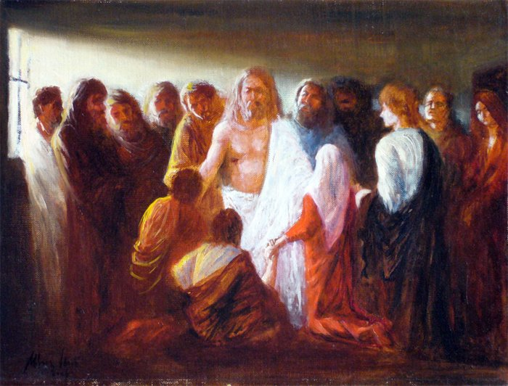

May the celebration of resurrected life bring new hope to your being.
May the victory over earthly death turn your eyes to the promises of heaven.
May the empty tomb help you to leave your sorrows at the foot of the cross.
So that God's hope, promises and forgiveness reign in your life forever.
Amen.

