Gathering Words – The Beat of Life

Call to Worship
L: Christ has risen
ALL: CHRIST HAS RISEN INDEED
L: Faith, hope, and joy are alive
ALL: WE ARE EASTER PEOPLE - ALLELUIA

Praise Jesus is Lord!

Gathering Prayer

The Story

Praise He is Lord

Reflective Action

Prayer

Praise Jesus is Lord!

Benediction

He is Lord, He is Lord,
He is risen from the dead
And he is Lord.
Every knee shall bow,
Every tongue confess
That Jesus Christ is Lord.

He is love, he is love,
He has shown us by his life
that he is love;
All his people sing
with one voice of joy
That Jesus Christ is love.
He is life, he is life;
He has died to set us free
and he is life;
And he calls us all
to live evermore,
For Jesus Christ is life

Jesus is Lord! Creation’s voice proclaims it,
For by His power each tree and flower was planned and made.
Jesus is Lord! The universe declares it;
sun, moon and stars in heaven cry: Jesus is Lord!
Jesus is Lord! Jesus is Lord!
Praise Him with ‘Hallelujahs’, for Jesus is Lord!

Jesus is Lord! O’er sin the mighty conqueror,
from death He rose and all His foes shall own His name.
Jesus is Lord! God sends His Holy Spirit
to show by works of power that Jesus is Lord.
Jesus is Lord! Jesus is Lord!
Praise Him with ‘Hallelujahs’, for Jesus is Lord!

______________________________________________________

Lead us Lord

Lord of Life, you walk this journey with us and through us
LEAD US LORD, LEAD ON

Journeying within, and wrestling with the world
LEAD US LORD, LEAD ON

Lead us to risk, grow, and tread the path you have opened for us;
LEAD US LORD, LEAD ON

And let us rejoice that every place is your place;
IN THE NANE OF JESUS CHRIST THE RISEN ONE

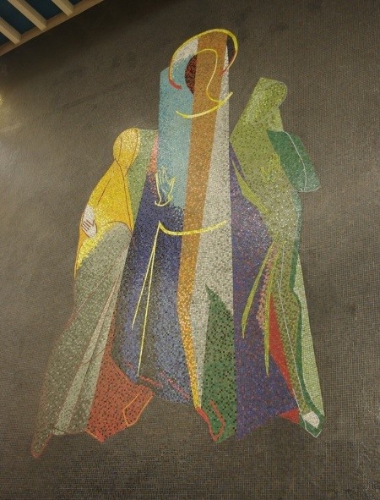

(Artist: John Piper (1903-1992, British)

EASTER SUNRISE SERVICE- KAY PARK
Sunday 31 March 2024, 7.30am
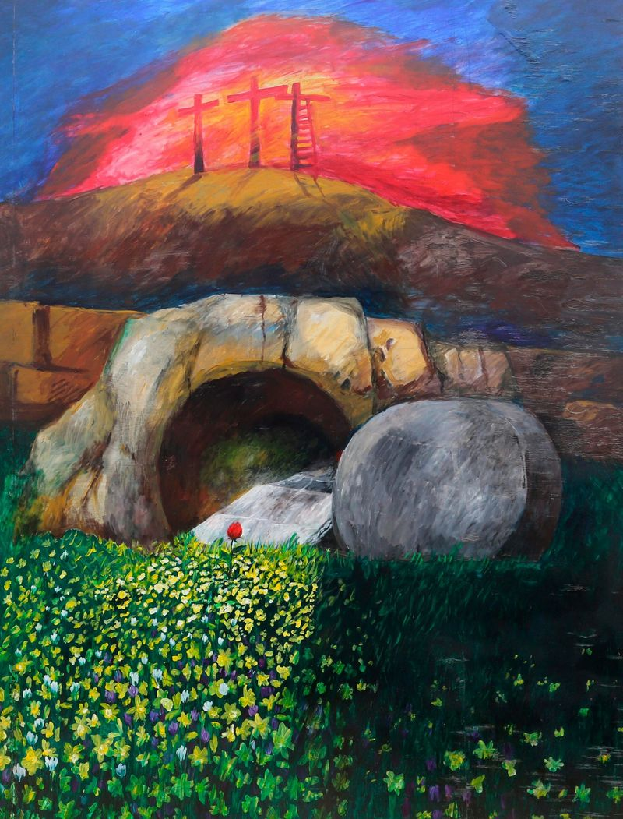
Service led by Rev Fiona Maxwell
Music from Alex Ferguson & Stacey Connell

Please join us for breakfast served in
Kay Park Church Halls

EVERYONE WELCOME!

