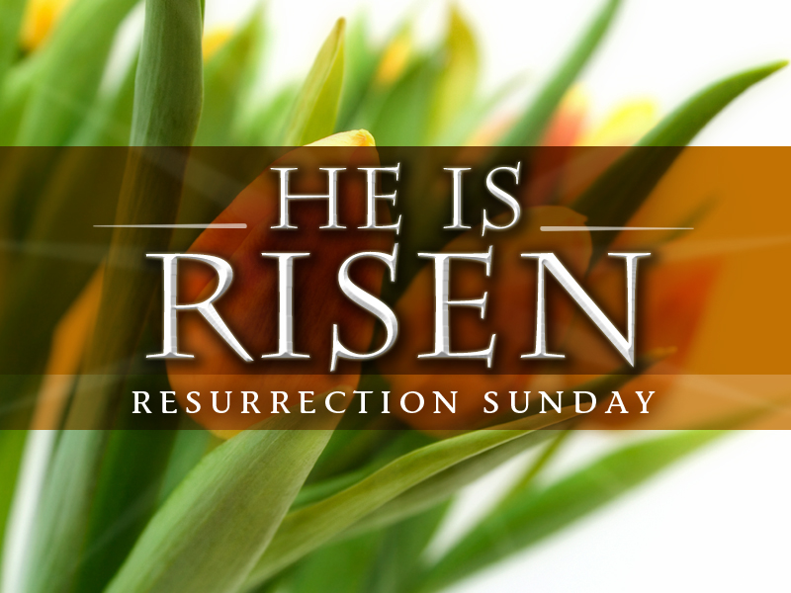

Christ is risen
Christ is risen, indeed!

The good news of resurrection is personal. It is for you. It is for any death-dealing circumstance that feels impossible in your life. It is for any relationship that needs to be risen from the grave.

The good news is for the whole world. The gift of new life is cause for running, for celebration, for eager sharing and a joy-filled life. Because Christ is risen, we can be risen here and now. We can wake up to life with excitement. We can hold on to and live into and boldly claim abundant life in Jesus Christ. Share the good news!

Happy Easter to one and all from Kay Park Parish Church

