The vision of the Church of Scotland is to be a church which seeks to inspire the people of Scotland and beyond with the Good News of Jesus Christ through enthusiastic, worshipping, witnessing, nurturing and serving communities.

Entry of the Bible
(we stand as the Bible is brought into church)

Welcome - Grace & Call to Worship

Praise 231 For the Fruits of all creation

Prayer of Approach and the Lord’s Prayer

The Story “Parable of the Sower” (video)

Praise Creation Sings
(choir to sing first verse and chorus)

Dramatised Reading

REFLECTION AND CRAFT TIME

Praise 229 We plough the Fields

PRAYER OF THANKSGIVING AND DEDICATION OF HARVEST GIFTS

Praise MP167 Give me joy in my heart (omit v 2)

Benediction

Notices
A warm welcome is extended to everyone this morning and especially to any visitors worshipping with us today.

Please take a few minutes to read the screens as there may be information, which was received too late for the printed intimations.

Our minister, the Rev. Fiona Maxwell, can be contacted by telephone on 01563 521762, by mobile on 07507 312123 or by email, FMaxwell@churchofscotland.org.uk

The email address for the Church Administrator is kppcchurchoffice@gmail.com or phone 07394 173977. Please note the new email address for the church administrator.

If you are watching the service via live stream the digital order of service is available on the church website under the services page.

There is now creche and young church facilities in the side chapel, if you have children with you, please use this room as and when you need to.

Tea/coffee will be served after morning worship, please come down to the hall for a warm cuppa and even warmer chat and fellowship.

Jean Herbert will be taking orders for the Crossreach Christmas cards today, money must be received by today.

The Guild meet on Tuesday 10 October at 2pm when the speaker will be Rev Fiona Maxwell. All welcome. Guild fees will be collected on 24 October.

Wednesday Walkers meet at the Kay Park at 10am at the top car park near the Burns Centre, enjoy a walk round the park and a good chat and then have coffee/tea in the church café. All welcome.

Wednesday café is open every Wednesday morning from 10am – 12 noon. Please tell your friends and neighbours and come and enjoy the company and chat.

Reachout Together are holding an Autism Awareness Information Evening on Monday 23 October from 7pm – 9pm at Kay Park Church, please use the front door.
SHOEBOX APPEAL
2023 marks the 30th Anniversary of the Blythswood Shoebox Appeal. Since 1993 Blythswood has delivered over 2.5 million boxes to people in need. This is a further opportunity for us to share with people much less fortunate than we are. Some of us have already began collecting small items for our shoebox. Leaflets containing all the information needed are available on the table as you enter church and at the window at the office downstairs. If you haven’t made a start there is still time. Boxes should be covered in Christmas wrapping paper and brought to church on either 22nd or 29th October 2023.
Knitting patterns are available if you wish to knit a hat etc to put in your shoebox.

From Scotland to Taiwan exhibition is from 8 October to 31 October this year, opening ceremony will take place at 12:30 on 8 October combined with the Sunday service of the church. The exhibition space is the St. George's Tron Church of Scotland, Glasgow. Exhibition open from 10.30 – 16.30 Mon – Sat.

Foodbank- Items can still be left at the back of the church in the wicker basket, these items are then taken to the Salvation Army for their foodbank, supplies are required urgently, so please give generously.

New to Kay Park?
If you are new to Kay Park, please feel free to approach the Minister, Rev Fiona on (01536) 521762 or the Session Clerk, Janette Steven, (01563) 401209, for further information about the Church and Membership. If you would like information about giving to the church financially, please contact the Treasurer, Alex Steven on 01563 401209

Happy Anniversary
Congratulations to KPPC walking groups which celebrated their 10th anniversary on 1st October. The first walk took place on 1st October 2013 at the Dean Estate, when 18 walkers took part.
We now have 3 walking groups which meet regularly and cater for people with different walking abilities.
Strollers - meet monthly and “stroll“ for about an hour.
Striders - meet monthly and walk for about one and a half hours.
Wee Wednesday Walkers - meet every Wednesday at the Kay Park and “saunter“ for about 25 minutes.
After each group finishes its walk and chat, refreshment is taken at a convenient venue. Every Wednesday’s venue is the church cafe.
If you would like to try us out, please speak to David Miller or Bill Caldwell for further information. You’ll be made most welcome!
www.kayparkparishchurch.org.uk
(Registered Scottish Charity: SC008154)

Sunday 8 October 2023 Harvest Thanksgiving

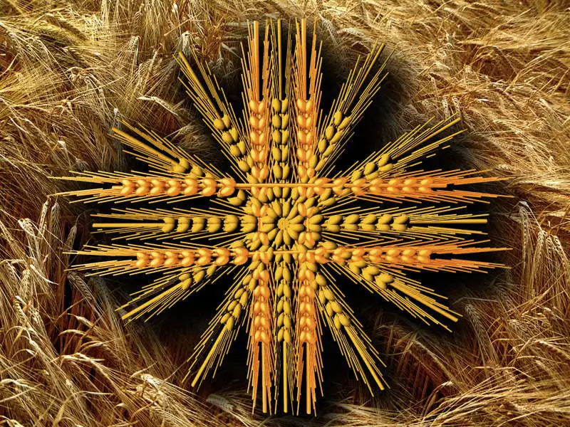

Minister
Rev. Fiona Maxwell

Organist
Mr Alex Ferguson

