The vision of the Church of Scotland is to be a church which seeks to inspire the people of Scotland and beyond with the Good News of Jesus Christ through enthusiastic, worshipping, witnessing, nurturing and serving communities.

Entry of the Bible (we stand as the Bible is brought into church)

Grace and Call to Worship

Praise 531 My Jesus, My Saviour

Prayer of Approach and Lord’s Prayer

CHAT TO ALL

Praise 516 We are marching in the light of God

Bible Reading John 4 v 7-15; 27-29 (pg 1066)
(Aileen Sansum)

Praise 619/620 Spirit of the Living God

REFLECTION ON GOD’S WORD

Praise 550 As the deer pants for the water

Prayers of Thanksgiving and for others

Praise 167 Guide me, O Thou Great Jehovah

Benediction

Notices

A warm welcome is extended to everyone this morning and especially to any visitors worshipping with us today.

Please take a few minutes to read the screens as there may be information, which was received too late for the printed intimations.

Our minister, the Rev. Fiona Maxwell, can be contacted by telephone on 01563 521762, or by email, FMaxwell@churchofscotland.org.uk

The email address for the Church Administrator is kppcchurchoffice@gmail.com or phone 07394 173977.

If you are watching the service via live stream the digital order of service is available on the church website under the services page.

Reminder If you have a hearing device, please make sure you have put it to the ‘T‘ position to enable it to link up with the church loop system.

Tea/coffee will be served after morning worship, please come down to the hall for a warm cuppa and even warmer chat and fellowship.

The Guild meet on Tuesday 10 March at 2pm when they will be entertained by Chords of Hope.

Strollers' walk will be on Wednesday 11th March. Assemble for 10am in the car park behind the Co-op at Hurlford Cross.

Wednesday Walkers meet at the Kay Park at 10am at the top car park near the Burns Centre, enjoy a walk round the park and a good chat. All welcome.

Wednesday Café 10am – 12 noon all welcome for a cuppa and chat.

Faith Stories Wednesday 11 March at 7pm in the café area of the church.

Next Sunday 15 March we will welcome Kate Freedman to join in our morning service. Kate is the development and fundraising officer for Tabeetha School in Jaffa and she will speak about her work and the amazing work that the school do.

Craft Fayre at KPPC Saturday 21 March 10am – 4pm Stalls, raffle, bottle stall, refreshments.
Foodbank- Items can still be left at the back of the church in the wicker basket, these items are then taken to the Salvation Army for their foodbank, supplies are required urgently, so please give generously.

New to Kay Park?
If you are new to Kay Park, please feel free to approach the Minister, Rev Fiona on (01563) 521762 or the Session Clerk, Jean Johnston, 07944 891078, for further information about the Church and Membership. If you would like information about giving to the church financially, please contact the Treasurer, Gordon Slater 07768 780051

Stamps If you are one of the few people who still gets letters with stamps we are looking for your stamps. There will be a box in the café area for you to put them, these will then be trimmed and sent away to Embrace the Middle East or Mercy Ships.

HELP The hospitality team are looking for 1 or 2 new members to join their team. Please contact Moira Graham moiragraham25@yahoo.com. Thank you.

Advance Notice The Annual, Aeolian Male Voice Choir Spring Concert will this year be held on Saturday, 9th May, at 2.00pm in the Howard Centre, Kilmarnock, with the Abertillery Male Voice Choir from Wales as our guests.
Tickets from your usual contacts will be available soon.

Community Litterpicks 2026 - There are plans to have 3 Community Litterpicks in 2026 supported by KPPC, the New Laigh Church, the Howard Centre and East Ayrshire Council. The following dates have been proposed - Saturday 11th April at the Howard Centre, 20th June at New Laigh Parish Church and 12th September at Kay Park Parish Church. EAC will supply all the picking equipment, gloves, sacks etc and will support the Litterpick afterwards with a Burger van. Each Litterpick will start at 10.00am. Anyone interested should give their names to Jeff Davies after the Church Service or text him on 07917 360887'.

The latest edition of Newsbite (the Church magazine) is now available at the back of the church, please take one if you don’t get one delivered or if you are visiting the church.


www.kayparkparishchurch.org.uk
(Registered Scottish Charity: SC008154

Lent 2
Sunday 8 March 2026

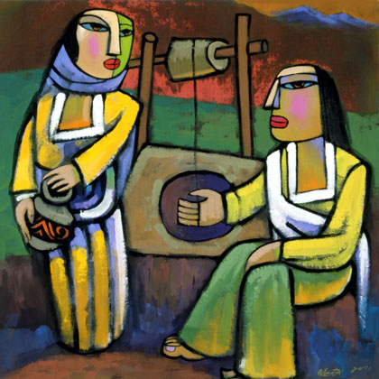

Minister
Rev Fiona Maxwell

Lead Musician
Mr Alex Ferguson

