The vision of the Church of Scotland is to be a church which seeks to inspire the people of Scotland and beyond with the Good News of Jesus Christ through enthusiastic, worshipping, witnessing, nurturing and serving communities.

Entry of the Bible (we stand as the Bible is brought into church)

Grace and Call to Worship

Praise 202 Stand up and bless the Lord

Prayer of Approach and Lord’s Prayer

Bible Reading
Old Testament: Deuteronomy 30 v 15-20 (pg 208)
(Audrey Gray)

Praise 608 Spirit of truth and grace

REFLECTION ON GOD’S WORD

Praise 19 Ye Gates, lift up your heads

SACRAMENT OF HOLY COMMUNION

Prayers of Thanksgiving and for others

Praise 519 Love Divine (Tune: Hyfrydol)

Benediction

Notices

A warm welcome is extended to everyone this morning and especially to any visitors worshipping with us today.

Please take a few minutes to read the screens as there may be information, which was received too late for the printed intimations.

Our minister, the Rev. Fiona Maxwell, can be contacted by telephone on 01563 521762, or by email, FMaxwell@churchofscotland.org.uk

The email address for the Church Administrator is kppcchurchoffice@gmail.com or phone 07394 173977.

If you are watching the service via live stream the digital order of service is available on the church website under the services page.

Reminder If you have a hearing device, please make sure you have put it to the ‘T‘ position to enable it to link up with the church loop system.

Tea/coffee will be served after morning worship, please come down to the hall for a warm cuppa and even warmer chat and fellowship.

Strollers' walk will be on Wednesday 10th September. Assemble for 10am in the car park off Loudoun St, Mauchline. Postcode for sat-nav is KA5 5BU

Wednesday Walkers meet at the Kay Park at 10am at the top car park near the Burns Centre, enjoy a walk round the park and a good chat. All welcome.

Wednesday café 10am – 12noon, come for a cuppa and chat, all are welcome.

Doors Open Day Saturday 13 September, the church will be open again this year from 1pm – 4pm to welcome visitors to our beautiful building.

DOORS OPEN DAY Saturday 13th September the Church will be open to welcome visitors from 1pm – 4pm.

Guild week - Songs of Praise, New Cumnock Parish Church, Tuesday 16th September 2025, 2 pm Tea/Coffee and Biscuits afterwards.

Kirk Session will meet on Wednesday 17 September at 7pm in the hall.

Fellowship of Kilmarnock Churches August Newsletter is now available at the back of the church.

Foodbank- Items can still be left at the back of the church in the wicker basket, these items are then taken to the Salvation Army for their foodbank, supplies are required urgently, so please give generously.

New to Kay Park?
If you are new to Kay Park, please feel free to approach the Minister, Rev Fiona on (01563) 521762 or the Session Clerk, Jean Johnston, 07944 891078, for further information about the Church and Membership. If you would like information about giving to the church financially, please contact the Treasurer, Gordon Slater 07768 780051

Stamps If you are one of the few people who still gets letters with stamps we are looking for your stamps. There will be a box in the café area for you to put them, these will then be trimmed and sent away to Embrace the Middle East or Mercy Ships.

Millport Sponsored Cycle -Fiona McBride will be doing a sponsored cycle round Millport on Saturday 20th September in order to raise funds in memory of her brother who passed away from cancer last year. All funds raised will go to "The Fraser McBride Foundation" which was set up in his memory to support charities through donations that support those living with cancer and those who are trying to find a cure.. If you are in a position to sponsor financially you can do so by speaking to Vanessa Twomey on a Sunday morning

Church Outing June 13/14 2026. Going to Alnwick & staying at the White Swan Hotel in Alnwick on Sat 13 June. Sunday 14 June Sunday service on Lindisfarne, coming home via the Borders and having high tea at the Tontine Hotel in Peebles.
Cost PP if sharing a room £160
If single room/occupancy £198
If interested, please confirm with Janette Steven 07788 298355
Alex Steven will be running a bank if people wish to pay up on a weekly or monthly basis.

Blythswood Shoebox Appeal
I hope you are managing to fill your shoeboxes for Blythswood Care. Leaflets giving more information are available at the rear of the church. A leaflet needs to accompany each box. Boxes should be brought to church the last Sunday in October.


www.kayparkparishchurch.org.uk
(Registered Scottish Charity: SC008154)

Sunday 7 September 2025

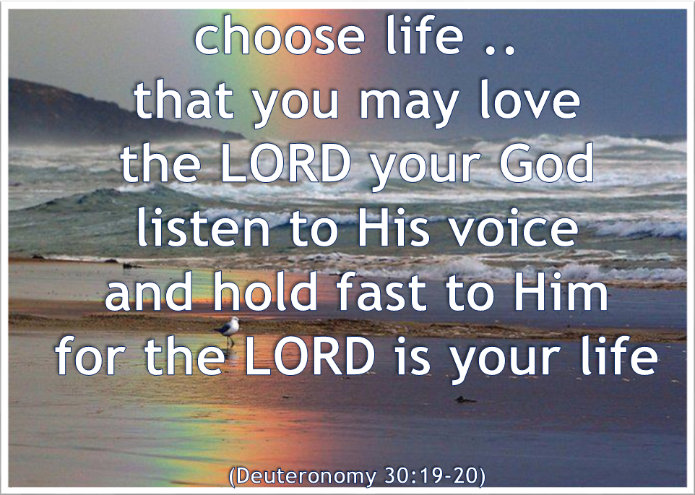

Minister
Rev Fiona Maxwell

Organist
Mr Charles Donnelly

