The vision of the Church of Scotland is to be a church which seeks to inspire the people of Scotland and beyond with the Good News of Jesus Christ through enthusiastic, worshipping, witnessing, nurturing and serving communities.

Entry of the Bible
(we stand as the Bible is brought into church)

Welcome and Notices

Introit

Grace & Call to Worship

Praise 436 Christ Triumphant
(Tune: Guiting Power)

Prayer of Approach and the Lord’s Prayer

Bible Reading Matthew chapter 20 v 20 – 28 (pg 988)
(Olive Caldwell)
Reflection on God’s Word – ‘Called to Serve’

Praise 374 From heaven you came

Celebration of Holy Communion
Young Church

Praise 481 Jesus is the name we honour (v1&2)

Prayers of Thanksgiving and for Others

Praise 459 Crown him with many crowns

Benediction

Notices
A warm welcome is extended to everyone this morning and especially to any visitors worshipping with us today.

Please take a few minutes to read the screens as there may be information, which was received too late for the printed intimations.

Our minister, the Rev. Fiona Maxwell, can be contacted by telephone on 01563 521762, by mobile on 07507 312123 or by email, FMaxwell@churchofscotland.org.uk

The email address for the Church Administrator is chrchdmnstr@outlook.com. or phone 07394 173977

If you are watching the service via live stream the digital order of service is available on the church website under the services page.

There is now creche and young church facilities in the side chapel, if you have children with you, please use this room as and when you need to.

Tea/coffee will be served after morning worship, please come down to the hall for a warm cuppa and even warmer chat and fellowship.

Scalliwags meet Monday at 9.30am – 11am. The group is for all children under 3 and should be accompanied by an adult.

Brownies & Guides 17th Kilmarnock Brownies and 6th Kilmarnock Guides will meet in the church halls on Monday at 6pm and 7.30pm.

Wednesday café is open every Wednesday morning from 10am – 12 noon. Please tell your friends and neighbours and come and enjoy the company and chat.

Kirk Session Wednesday 10 May at 7.30pm in the Sanctuary.

The Christian Aid Family Quiz afternoon is next Saturday 13 May at 2pm, please make sure you have a ticket.

Foodbank- Items can still be left at the back of the church in the wicker basket, these items are then taken to the Salvation Army for their foodbank, supplies are required urgently, so please give generously.
Some items that are often forgotten are: Tin Openers, Toiletries, Toilet Rolls, Detergent/washing up liquid, Nappies and other baby supplies, Free from all items e.g Gluten Free

A collection for Christian Aid in Tesco Extra, West Shaw Street, Kilmarnock will take place on Saturday, 20th May. Christian Aid collecting buckets and tabards will be provided. If anyone from your church can help, I would be most grateful if you could contact Helen Colman, E: helenmcolman@gmail.com preferably. You can also telephone 01563 524259.
Thanks for your help.

Kilmarnock to Formosa (Taiwan) on Thursday 1 June 2023 at 7pm in Kay Park Parish Church. Guest speaker Dr David Lui from Taiwan will share with us the remarkable story of missionaries who left Scotland and travelled to work in Taiwan. Refreshments will then be served in the church hall. All welcome.

Summer
Alex Ferguson will finish with us on Sunday 28 May for his summer break. During the summer we will have my friend, Charles Donnelly, (charles.donnelly203@outlook.com) with us and also be assisted on certain weeks by Grant Donald, (jaromigh@gmail.com)

The funeral of Linda Skeoch will take place on Tuesday 16 May at 10.45 in the church.

Organ Recital at St Josephs Church, Kilmarnock, at 7.30pm on 19 May 2023 - Raymond McCluskey.

www.kayparkparishchurch.org.uk
(Registered Scottish Charity: SC008154)

Easter 5
7 May 2023

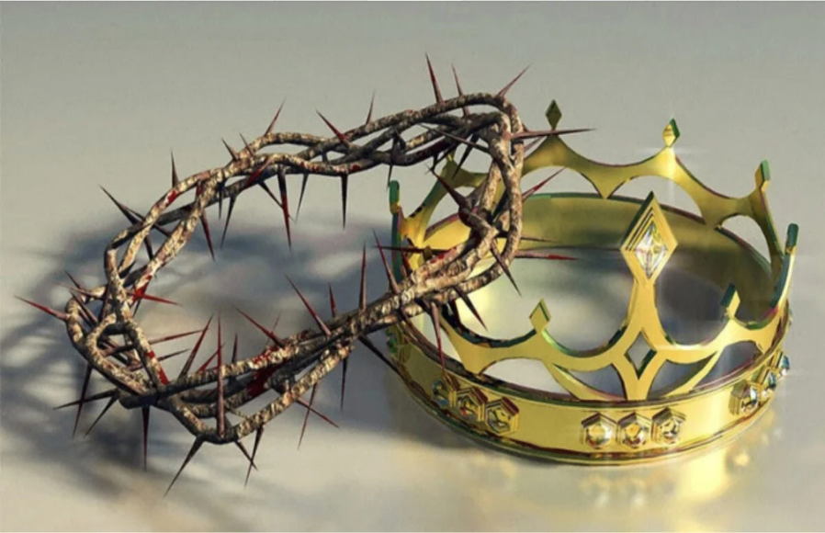
Minister
Rev. Fiona Maxwell

Organist
Mr Alex Ferguson

