The vision of the Church of Scotland is to be a church which seeks to inspire the people of Scotland and beyond with the Good News of Jesus Christ through enthusiastic, worshipping, witnessing, nurturing and serving communities.

Entry of the Bible
(we stand as the Bible is brought into church)
Introit

Welcome - Grace & Call to Worship

Praise 324 Angels from the Realms of glory (omit v 2)

Prayer of Approach and Lord’s Prayer

Bible Reading Isaiah 60 v 1 – 6 (pg 748)

Praise 331 Unto us is born a son

Bible Reading Matthew chapter 2 v 1-12 (pg 966)

Praise 288 Creator of the stars of night

Reading Strange Gifts to Give a Child, by Ken Taylor

Reflective Music

Reading The Magi at the Empty Manger by Godfrey Rust

Praise 326 As with Gladness men of old

Reading For those who have far to travel by Jan Richardson

Prayers of Thanksgiving and for others

Praise 237 Look forward in Faith

Benediction

The feast of Epiphany today brings the Christmas season to an end. To mark the day, here’s a litany called “The Work of Christmas” composed by Howard Thurman, an African-American theologian, educator, and civil rights leader.
When the song of the angels is stilled,
when the star in the sky is gone,
when the kings and princes are home,
when the shepherds are back with their flocks,
the work of Christmas begins:
to find the lost,
to heal the broken,
to feed the hungry,
to release the prisoner,
to rebuild the nations,
to bring peace among the people,
to make music in the heart.

Instrument of Peace
After St Francis

To the ice of hate To the snowstorm of sadness
May I be an axe of love A shelter of joy

To frostbitten injury To long nights of darkness
The salve of pardon A lantern of light

To cold waters of doubt Mary Palmer
A bridge of faith

To the dark soli of despair
A seed of hope

Notices

A warm welcome is extended to everyone this morning and especially to any visitors worshipping with us today.

Please take a few minutes to read the screens as there may be information, which was received too late for the printed intimations.

Our minister, the Rev. Fiona Maxwell, can be contacted by telephone on 01563 521762, by mobile on 07507 312123 or by email, FMaxwell@churchofscotland.org.uk

The email address for the Church Administrator is kppcchurchoffice@gmail.com or phone 07394 173977. Please note the new email address for the church administrator.

There is now creche and young church facilities in the side chapel, if you have children with you, please use this room as and when you need to.

Tea/coffee will be served after morning worship, please come down to the hall for a warm cuppa and even warmer chat and fellowship.

Strollers meet on Monday 8 January at 10am in the car park of the Burns Centre, Alloway. (KA7 4PQ). All welcome.

The funeral of Ms Karen Presly will take place on TUESDAY, 9 January at 11.15am in Kay Park Parish Church and thereafter at 12.30 in Holmsford Bridge Crematorium. Please remember Karen's family and friends in your prayers.

Wednesday Walkers meet at the Kay Park at 10am at the top car park near the Burns Centre, enjoy a walk round the park and a good chat and then have coffee/tea in the church café. All welcome.

Wednesday café is open every Wednesday morning from 10am – 12 noon. Please tell your friends and neighbours and come and enjoy the company and chat.

Friendship Club meet on Thursday 11 January at 2pm for cake decorating with Lynette Russell. All welcome.

Fellowship of Kilmarnock Churches are having a Christian Unity Service on Sunday 21 January at 3pm in St Marnocks Church, to mark the Week of Prayer for Christian Unity.

www.kayparkparishchurch.org.uk
(Registered Scottish Charity: SC008154)

Sunday 7 January 2024
EPIPHANY
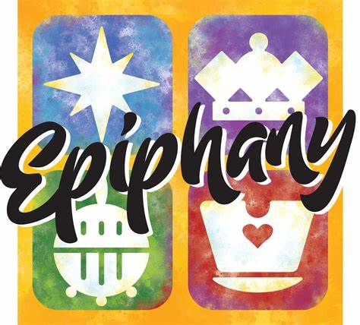
Minister
Rev. Fiona Maxwell

Organist
Mr Alex Ferguson

