The vision of the Church of Scotland is to be a church which seeks to inspire the people of Scotland and beyond with the Good News of Jesus Christ through enthusiastic, worshipping, witnessing, nurturing and serving communities.

Entry of the Bible (we stand as the Bible is brought into church)

Grace and Advent Call to Worship

Praise 472 Come thou Long expected Jesus

Prayer of Approach and Lord’s Prayer

Praise 279 Make Way, Make Way

Bible Reading Matthew 3 v 1- 3 (pg 967)
Luke 1 v 46b – 55 (pg 1026)

Praise 291 When out of poverty is born

REFLECTION ON GOD’S WORD

Video Reflection ‘The Yearning’

Prayers of Thanksgiving and for others

Praise 286 Tell out my soul

Benediction

Notices

A warm welcome is extended to everyone this morning and especially to any visitors worshipping with us today.

Please take a few minutes to read the screens as there may be information, which was received too late for the printed intimations.

Our minister, the Rev. Fiona Maxwell, can be contacted by telephone on 01563 521762, or by email, FMaxwell@churchofscotland.org.uk

The email address for the Church Administrator is kppcchurchoffice@gmail.com or phone 07394 173977.

If you are watching the service via live stream the digital order of service is available on the church website under the services page.

Reminder If you have a hearing device, please make sure you have put it to the ‘T‘ position to enable it to link up with the church loop system.

Tea/coffee will be served after morning worship, please come down to the hall for a warm cuppa and even warmer chat and fellowship.

Wednesday Walkers meet at the Kay Park at 10am at the top car park near the Burns Centre, enjoy a walk round the park and a good chat. All welcome.

Wednesday Café 10am – 12 noon all welcome for a cuppa and chat.

Friendship Club meets on Thursday 11 December for A Christmas Extravaganza. All Welcome

Strollers and Striders meet on Saturday 13 December at 10am in the car park at Dean Castle Country Park.

Christmas in Music Sunday 14 December at 11am led by the Church Choir.

Christmas Lunch Sunday 14 December down in the hall after the service.

St Sophia's Church in Galston are having a special carol concert on Sunday 14 December at 7 p.m. This will include "angelic voices" from Irvine Valley Church and St Sophia's Church.

Advance Notice
Heartstart are running a CPR Training course on Wednesday 14 January at 7pm. If you are interested in coming to this event please speak to John Dyet.

Foodbank- Items can still be left at the back of the church in the wicker basket, these items are then taken to the Salvation Army for their foodbank, supplies are required urgently, so please give generously.

New to Kay Park?
If you are new to Kay Park, please feel free to approach the Minister, Rev Fiona on (01563) 521762 or the Session Clerk, Jean Johnston, 07944 891078, for further information about the Church and Membership. If you would like information about giving to the church financially, please contact the Treasurer, Gordon Slater 07768 780051

Stamps If you are one of the few people who still gets letters with stamps we are looking for your stamps. There will be a box in the café area for you to put them, these will then be trimmed and sent away to Embrace the Middle East or Mercy Ships.

Fellowship of Kilmarnock Churches latest newsletter is available at the back of the church, please take one if you wish.

Fiona Kendall – Mission Partner Newsletter is available at the back of the church, please feel free to take one.

The latest edition of Newsbite Winter 2025 is now available at the back of the church, please take one if you don’t get it delivered by an Elder.

The BIG CHRISTMAS CARD is available in the vestibule for anyone wishing to sign it and make a donation to Mediterranean Hope.

Advent Booklets are at the back of the church if you would like to take one.

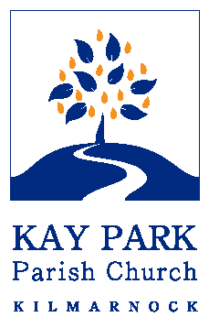
www.kayparkparishchurch.org.uk
(Registered Scottish Charity: SC008154

SECOND SUNDAY IN ADVENT
Sunday 7 December 2025

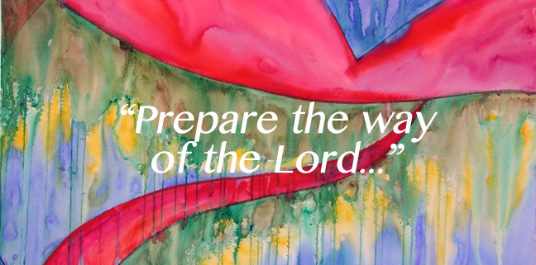

Minister
Rev Fiona Maxwell

Organist
Alex Ferguson

