The vision of the Church of Scotland is to be a church which seeks to inspire the people of Scotland and beyond with the Good News of Jesus Christ through enthusiastic, worshipping, witnessing, nurturing and serving communities.

Entry of the Bible
(we stand as the Bible is brought into church)

Welcome and Notices

Grace & Call to Worship

Praise 153 Great is thy Faithfulness

Prayer of Approach and the Lord’s Prayer

Praise 694 Brother, sister let me serve you (v 1 -3)

Bible Reading Mark chapter 6 v 30 – 44 (Pg 1009)
(Shiona Thomson)
Praise 694 Brother, sister let me serve you (v 4-6)

Reflection on God’s Word

Praise 291 When out of poverty is born

Prayers of Thanksgiving and for Others

Praise 680 You are called to tell the story

Benediction

Notices
A warm welcome is extended to everyone this morning and especially to any visitors worshipping with us today.

Please take a few minutes to read the screens as there may be information, which was received too late for the printed intimations.

Our minister, the Rev. Fiona Maxwell, can be contacted by telephone on 01563 521762, by mobile on 07507 312123 or by email, FMaxwell@churchofscotland.org.uk

The email address for the Church Administrator is chrchdmnstr@outlook.com. or phone 07394 173977. The church email address is still causing problems, if you email Vanessa and she doesn’t respond, try contacting her by phone. Thank you

If you are watching the service via live stream the digital order of service is available on the church website under the services page.

There is now creche and young church facilities in the side chapel, if you have children with you, please use this room as and when you need to.

Tea/coffee will be served after morning worship, please come down to the hall for a warm cuppa and even warmer chat and fellowship.

Young Church are taking a break for the summer, but the side chapel is still available for those who want to use it throughout the summer months.

Strollers meet on Tuesday 8 August at 10am at the entrance to Lainshaw Woods on David Dale Street, Stewarton. This is first left at the mini-roundabout as you enter Stewarton from Kilmarnock. Our walk will be through the woods and alongside the river before returning to Stewarton on country roads. Refreshments afterwards will be at The Millhouse in Stewarton.

Organ Recital at St Joseph’s RC Church Tuesday 8 August at 12 noon all welcome

Wednesday Walkers meet at the Kay Park at 10am at the top car park near the Burns Centre, enjoy a walk round the park and a good chat and then have coffee/tea in the church café. All welcome.

Wednesday café is open every Wednesday morning from 10am – 12 noon. Please tell your friends and neighbours and come and enjoy the company and chat.

Advance Notice - The Friendship Club meet for Coffee & Chat on Thursday 17 August at 2pm in the Church Café. All Welcome
Holiday Clubs
“Diary of a Disciple” Summer Holiday Club for Primary School Children: Mon 7th – Fri 11th August 10.30 till12 noon in St Kentigern's Church Hall. If you are PVG-cleared and would be interested in helping at the holiday club then please contact Anne McCabe 07780 755878 for more information.

Safari Summer Club 14 – 16 August at New Laigh Kirk Church Halls from 6pm to 8pm for all Primary 1 – 7 children. All Welcome

Welcoming Team
The welcoming team are an important part of Sunday morning worship. We urgently need new volunteers to join the team so if you are willing to be on once every 8 weeks, please speak to Janette Steven. The duties include welcoming people as they arrive and then being at the door at the end of worship to see people on their way.

Foodbank- Items can still be left at the back of the church in the wicker basket, these items are then taken to the Salvation Army for their foodbank, supplies are required urgently, so please give generously.

Newsbite The next edition of the Church Newsbite is due for publication towards the end of August. This is your magazine, and I would love to hear from you about what you want to read. You can also submit an article if you want, this might be a book review, podcast, TV programme that you have found interesting and helpful. Or it might be a place you have visited over the summer. Please send your ideas/articles to Vanessa at chrchdmnstr@outlook.com

www.kayparkparishchurch.org.uk
(Registered Scottish Charity: SC008154)

6 August 2023
10th Sunday after Pentecost

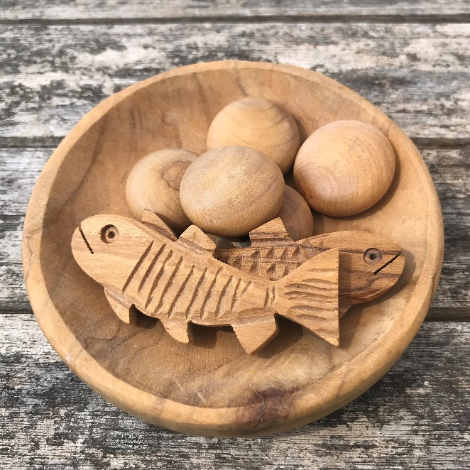

Minister
Rev. Fiona Maxwell

Organist
Mr Grant Donald

