The vision of the Church of Scotland is to be a church which seeks to inspire the people of Scotland and beyond with the Good News of Jesus Christ through enthusiastic, worshipping, witnessing, nurturing and serving communities.

Entry of the Bible (we stand as the Bible is brought into church)

Grace and Call to Worship

Praise CH4 111 Holy, holy, holy

Prayer of Approach and Lord’s Prayer

Young at heart time

Praise CH4 448 Shine Jesus shine

Bible Readings Psalm 8 (pg 546)
Matthew 28:16-20 (pg 1000)
(Janette Tennant)

Praise CH4 260 Eternal Father, strong to save

REFLECTION on GOD’s WORD

Prayers of Thanksgiving and for others

Praise CH4 182 Now thank we all our God

Benediction

‘Go then to all peoples everywhere and make them my disciples; baptize them in the name of the Father, the Son and the Holy Spirit, and teach them to obey everything I have commanded you. And I will be with you always, to the end of the age.’ Matthew 28:19-20

Notices

A warm welcome is extended to everyone this morning and especially to any visitors worshipping with us today.

Please take a few minutes to read the screens as there may be information, which was received too late for the printed intimations.

Our minister, the Rev. Fiona Maxwell, can be contacted by telephone on 01563 521762, or by email, FMaxwell@churchofscotland.org.uk

The email address for the Church Administrator is kppcchurchoffice@gmail.com or phone 07394 173977.

If you are watching the service via live stream the digital order of service is available on the church website under the services page.

Reminder If you have a hearing device, please make sure you have put it to the ‘T‘ position to enable it to link up with the church loop system.

Tea/coffee will be served after morning worship, please come down to the hall for a warm cuppa and even warmer chat and fellowship.

Sunday Services The Minister is away the following two weekends, 29th May - 1st June and then 5th - 9th June. We warmly welcome Rev Jeanette Whitecross and Rev Taylor Brown to lead our worship.

Elizabeth Cook, wife of the late Rev John Cook, died last week and her funeral service will be at Mortonhall Crematorium on Mon 1st June 11 am.

Wednesday Walkers meet at the Kay Park at 10am at the top car park near the Burns Centre, enjoy a walk round the park and a good chat. All welcome.

Wednesday Café 10am – 12 noon all welcome for a cuppa and chat.

Friendship Club meet on Thursday 4 June in the café at 2pm for coffee and chat.

Strollers' walk will be on Saturday 6th June and will be around Eglinton Country Park, Kilwinning. Post code for sat-nav is KA12 8TA.

Holy Communion Sunday 7 June 11am.

Praise Night at Kay Park Parish Church - 7 June @ 7pm. You are invited to join KPPC's Choir and Praise Band for a relaxed hour of worship and praise. Details are on the attached poster. There will be a retiring offering for Ayrshire Cancer Support and Parkinson's UK.

The Stated Annual Meeting of the Congregation will take place on Sunday 14th June during the morning service.

Fellowship of Kilmarnock Churches next service will be on Sunday 14 June at 3 p.m. at Irvine Valley Parish Church. This will take place in the church building in Darvel, on the main street at Hastings Square. The theme will be Summer Songs of Praise.

Community Litterpick - The second Litterpick of the year will be held on Saturday 20th June based ar the New Laigh Parish Church in Kilmarnock at 9.30am. Anyone interested in supporting this important community project should contact Jeff Davies on 07917 701714 or email at jeffandsheila@talktalk.net All equipment will be supplied and bacon rolls with tea or coffee supplied free of charge.

Foodbank- Items can still be left at the back of the church in the wicker basket, these items are then taken to the Salvation Army for their foodbank, supplies are required urgently, so please give generously.

Stamps If you are one of the few people who still gets letters with stamps we are looking for your stamps. There will be a box in the café area for you to put them, these will then be trimmed and sent away to Embrace the Middle East or Mercy Ships.

New to Kay Park?
If you are new to Kay Park, please feel free to approach the Minister, Rev Fiona on (01563) 521762 or the Session Clerk, Jean Johnston, 07944 891078, for further information about the Church and Membership. If you would like information about giving to the church financially, please contact the Treasurer, Gordon Slater 07768 780051

Back by popular demand for 2026
Postcards from around the Globe
We would love to see where you’ve travelled to this holiday season. If you’re away for a holiday or just a day trip then either send us a postcard or bring one back and put it in the post box at the back of the church.
Kay Park Parish Church, London Road, Kilmarnock, KA3 7AA


www.kayparkparishchurch.org.uk
(Registered Scottish Charity: SC008154

Trinity Sunday 31 May 2026

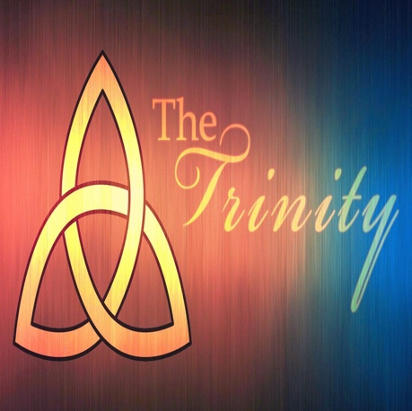

Visiting Minister
Rev Jeanette Whitecross

Lead Musician
Charles Donnelly

