The vision of the Church of Scotland is to be a church which seeks to inspire the people of Scotland and beyond with the Good News of Jesus Christ through enthusiastic, worshipping, witnessing, nurturing and serving communities.

Entry of the Bible (stand as the Bible is brought into church)

Introit

Welcome - Grace & Call to Worship

Praise 320 Joy to the World

Reading LIGHT LOOKED DOWN

Prayer of Approach and Lord’s Prayer

THE WORD based on John chapter 1 v 1-5; 10-14

Praise 329 O, Little love who comes again
(Tune: O Waly, Waly, (234)

Reading CHRIST IS NOT JUST FOR CHRISTMAS

Praise 316 Love came down at Christmas

REFLECTION ON GOD’S WORD
Anthem

Prayers of Thanksgiving and for others

Praise 303 It came upon a midnight clear

Benediction

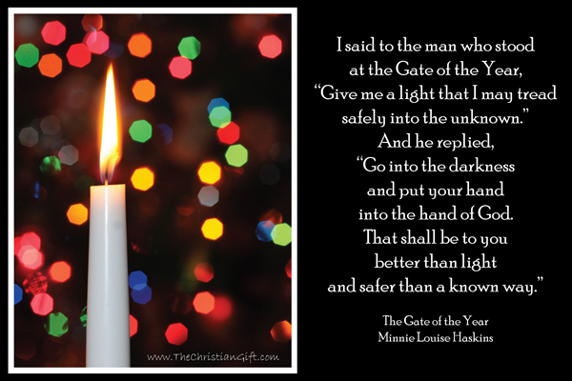

Notices

A warm welcome is extended to everyone this morning and especially to any visitors worshipping with us today.

Please take a few minutes to read the screens as there may be information, which was received too late for the printed intimations.

Our minister, the Rev. Fiona Maxwell, can be contacted by telephone on 01563 521762, by mobile on 07507 312123 or by email, FMaxwell@churchofscotland.org.uk

The email address for the Church Administrator is kppcchurchoffice@gmail.com or phone 07394 173977. Please note the new email address for the church administrator.

If you are watching the service via live stream the digital order of service is available on the church website under the services page.

There is now creche and young church facilities in the side chapel, if you have children with you, please use this room as and when you need to.

Tea/coffee will be served after morning worship, please come down to the hall for a warm cuppa and even warmer chat and fellowship.

Wednesday cafe will be closed on the 27th December and 3rd January. We will reopen on Wednesday 10th January.

The funeral of Ms Karen Presly will take place on TUESDAY, 9 January at 11.15am in Kay Park Parish Church and thereafter at 12.30 in Holmsford Bridge Crematorium. Please remember Karen's family and friends in your prayers.

Foodbank- Items can still be left at the back of the church in the wicker basket, these items are then taken to the Salvation Army for their foodbank, supplies are required urgently, so please give generously.

From Fiona, our Minister...

I would like to extend my sincere thanks for all the lovely Christmas Cards given to me this year and for all your ongoing love, support and prayers.
As the year draws to a close
- Thank you to our staff Vanessa, Paul and Robbie for their hard work over the year.
- Thank you to Alex Ferguson, Grant Donald and the Choir for their contribution to our worship and for leading us weekly in praise.
- Thank you to the Media Team for all your work on a Sunday and in preparation for a Sunday.
And finally, Thank you, to every one of you in the church family of Kay Park for all you 'are' and all you 'do' as a community of faith in service of God, one another and the wider community.

I wish you all God's Blessing this Christmas time and his abiding presence in the year to come.

'Not to us, O Lord, not to us but to your name be the glory because of your love and faithfulness' (Psalm 115v1)

with love, Rev Fiona.

www.kayparkparishchurch.org.uk
(Registered Scottish Charity: SC008154)

Sunday 31 December 2023

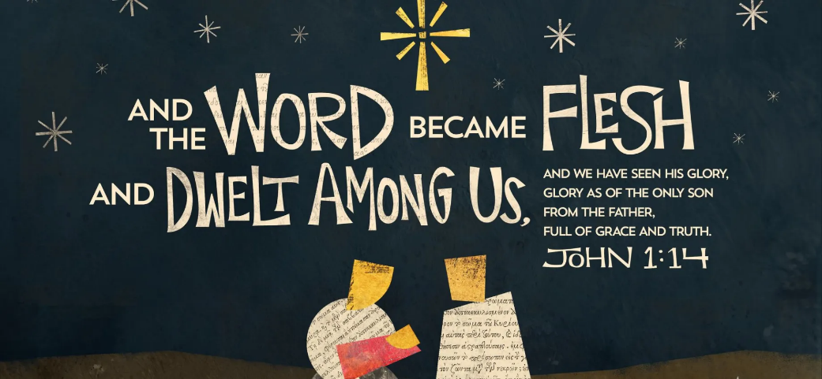

Minister
Rev. Fiona Maxwell

Organist
Mr Alex Ferguson

