The vision of the Church of Scotland is to be a church which seeks to inspire the people of Scotland and beyond with the Good News of Jesus Christ through enthusiastic, worshipping, witnessing, nurturing and serving communities.

Entry of the Bible (we stand as the Bible is brought into church)

Grace and Advent Call to Worship Jeff Davies

Praise Now the heavens start to whisper Jeff Davies
(Tune 590 Yr Hun Gan)
During this hymn Jean Johnston will come forward to light the first advent candle
Prayer of Approach and Lord’s Prayer Jeff Davies

Chat for all & DEDICATION OF GIFTS Bill Caldwell

Praise MP 42 At this time of giving Bill Caldwell

Bible Reading Isaiah 2 v 1-5 (pg 687)
(Janette Tennant)

Praise 710 I have a dream (v1-3)
Rev Jim McNaughtan

REFLECTION ON GOD’S WORD Rev Jim McNaughtan

Praise 710 I have a dream (v4&5)
Rev Jim McNaughtan

Prayers of Thanksgiving and for others Vanessa Twomey

Praise 709 The Right hand of God Jeff Davies

Blessing Jeff Davies

Notices

A warm welcome is extended to everyone this morning and especially to any visitors worshipping with us today.

Please take a few minutes to read the screens as there may be information, which was received too late for the printed intimations.

Our minister, the Rev. Fiona Maxwell, can be contacted by telephone on 01563 521762, or by email, FMaxwell@churchofscotland.org.uk

The email address for the Church Administrator is kppcchurchoffice@gmail.com or phone 07394 173977.

If you are watching the service via live stream the digital order of service is available on the church website under the services page.

Reminder If you have a hearing device, please make sure you have put it to the ‘T‘ position to enable it to link up with the church loop system.

Tea/coffee will be served after morning worship, please come down to the hall for a warm cuppa and even warmer chat and fellowship.

Christmas Trail today Sunday 30 November 1.30pm – 4pm, visit all the town churches and enjoy an activity at each church. Then head into the town for the switching on of the Christmas lights.

The Guild meet on Tuesday 2 December at 2pm when the speaker will be Karen Gillen who is the National Guild Convenor.

Wednesday Walkers meet at the Kay Park at 10am at the top car park near the Burns Centre, enjoy a walk round the park and a good chat. All welcome.

Wednesday Café 10am – 12 noon all welcome for a cuppa and chat.

Blue Christmas Sunday 7 December 3pm.

Foodbank- Items can still be left at the back of the church in the wicker basket, these items are then taken to the Salvation Army for their foodbank, supplies are required urgently, so please give generously.

New to Kay Park?
If you are new to Kay Park, please feel free to approach the Minister, Rev Fiona on (01563) 521762 or the Session Clerk, Jean Johnston, 07944 891078, for further information about the Church and Membership. If you would like information about giving to the church financially, please contact the Treasurer, Gordon Slater 07768 780051

Stamps If you are one of the few people who still gets letters with stamps we are looking for your stamps. There will be a box in the café area for you to put them, these will then be trimmed and sent away to Embrace the Middle East or Mercy Ships.

Christmas Lunch Sunday 14 December 12.15. Tickets for the Christmas Lunch will be on sale today Sunday 30 November at the church office at a suggested donation of £7.

Fellowship of Kilmarnock Churches latest newsletter is available at the back of the church, please take one if you wish.

Fiona Kendall – Mission Partner Newsletter is available at the back of the church, please feel free to take one.

The latest edition of Newsbite Winter 2025 is now available at the back of the church, please take one if you don’t get it delivered by an Elder.

The BIG CHRISTMAS CARD is available in the vestibule for anyone wishing to sign it and make a donation to Mediterranean Hope.

Advent Booklets are at the back of the church if you would like to take one.


www.kayparkparishchurch.org.uk
(Registered Scottish Charity: SC008154

FIRST SUNDAY IN ADVENT
Sunday 30 November 2025

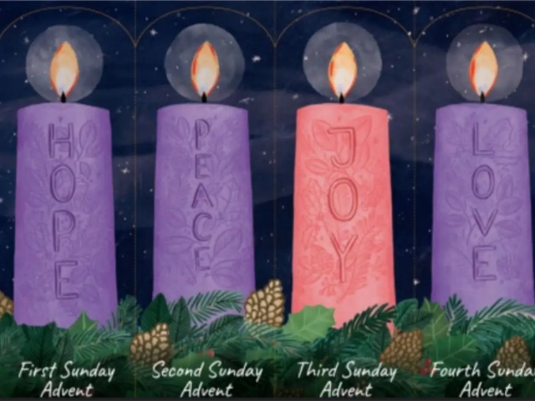

Minister
Rev Jim McNaughtan

Organist
Charles Donnelly

