The vision of the Church of Scotland is to be a church which seeks to inspire the people of Scotland and beyond with the Good News of Jesus Christ through enthusiastic, worshipping, witnessing, nurturing and serving communities.

Entry of the Bible
(We stand as the Bible is brought into church)
Introit

Grace & Call to Worship

Praise 111 Holy, holy, holy, Lord God almighty!

Prayer of Approach & Lord’s Prayer

Reflection: Bullets or Bridges?

Praise 337* Forty days and forty nights thou wast
(Tune: Harts) fasting in the wild;

Gospel Reading St. John 2:13-22.(pg 1065)
(Olive Caldwell)

Anthem: Let there be peace on earth.

Praise 484 Great God, your love has called us here,
as we, by love for love were made.

Reflection on God’s Word: Spring Cleaning.

Praise 549 How deep the Father’s love for us,
how vast beyond all measure,

Prayer of Thanks and Intercession

Praise 167. Guide me, O thou great Jehovah,
pilgrim through this barren land;

Benediction &Amen

Notices

A warm welcome is extended to everyone this morning and especially to any visitors worshipping with us today.

Please take a few minutes to read the screens as there may be information, which was received too late for the printed intimations.

Our minister, the Rev. Fiona Maxwell, can be contacted by telephone on 01563 521762, by mobile on 07507 312123 or by email, FMaxwell@churchofscotland.org.uk

The email address for the Church Administrator is kppcchurchoffice@gmail.com or phone 07394 173977. Please note the new email address for the church administrator.

If you are watching the service via live stream the digital order of service is available on the church website under the services page.

There is now creche and young church facilities in the side chapel, if you have children with you, please use this room as and when you need to.

Tea/coffee will be served after morning worship, please come down to the hall for a warm cuppa and even warmer chat and fellowship.

Friendship Club The recording of the meeting with Fiona Kendall has been sent to Fiona and is awaiting her approval before it is put online. Further details to follow soon.

Strollers will meet on Wednesday 6 March at 10am in the car park at Prestwick shorefront adjacent to Cafe Mancini (KA9 1QG). All welcome.

Wednesday Walkers meet at the Kay Park at 10am at the top car park near the Burns Centre, enjoy a walk round the park and a good chat and then have coffee/tea in the church café. All welcome.

Wednesday café is open every Wednesday morning from 10am – 12 noon. Please tell your friends and neighbours and come and enjoy the company and chat.

FAITH STORIES - Wednesday 6 March, 7pm
You are all welcome as we gather in the Church Cafe area to listen to stories of faith, chat and discover together.
(PLEASE NOTE THE 'GUEST' WILL BE REV FIONA MAXWELL NOT THE REV JILL CLANCY, who instead will join us on Wednesday 13 March)

Friendship Club Thursday 7 March at 2pm when the entertainment will be the Aeolian Concert Party. All Welcome

The Fellowship of Kilmarnock Churches’ Good Friday Walk of Witness will take place on Friday 29th March. Please note a change of time to ensure we finish at The Cross just prior to the Good Friday Vigil, 12 noon at New Laigh Kirk. Gather from 10.30am outside the Salvation Army in Sturrock Street, as we aim to begin the Walk of Witness at 10.45am sharp.

24/7 PRAYER ROOM The Howard Centre will host a 24/7 Prayer Room throughout the first week of the school Easter holidays: Monday 1st – Sunday 7th April. Pray-in-person & pray-at-home slots are available. Please contact Elaine Wardrop at ewardrop@churchofscotland.org.uk to book a slot.

Foodbank- Items can still be left at the back of the church in the wicker basket, these items are then taken to the Salvation Army for their foodbank, supplies are required urgently, so please give generously.

New to Kay Park?
If you are new to Kay Park, please feel free to approach the Minister, Rev Fiona on (01536) 521762 or the Session Clerk, Janette Steven, (01563) 401209, for further information about the Church and Membership. If you would like information about giving to the church financially, please contact the Treasurer, Alex Steven on 01563 401209

www.kayparkparishchurch.org.uk
(Registered Scottish Charity: SC008154)

Sunday 3rd March 2024
3rd Sunday in Lent.

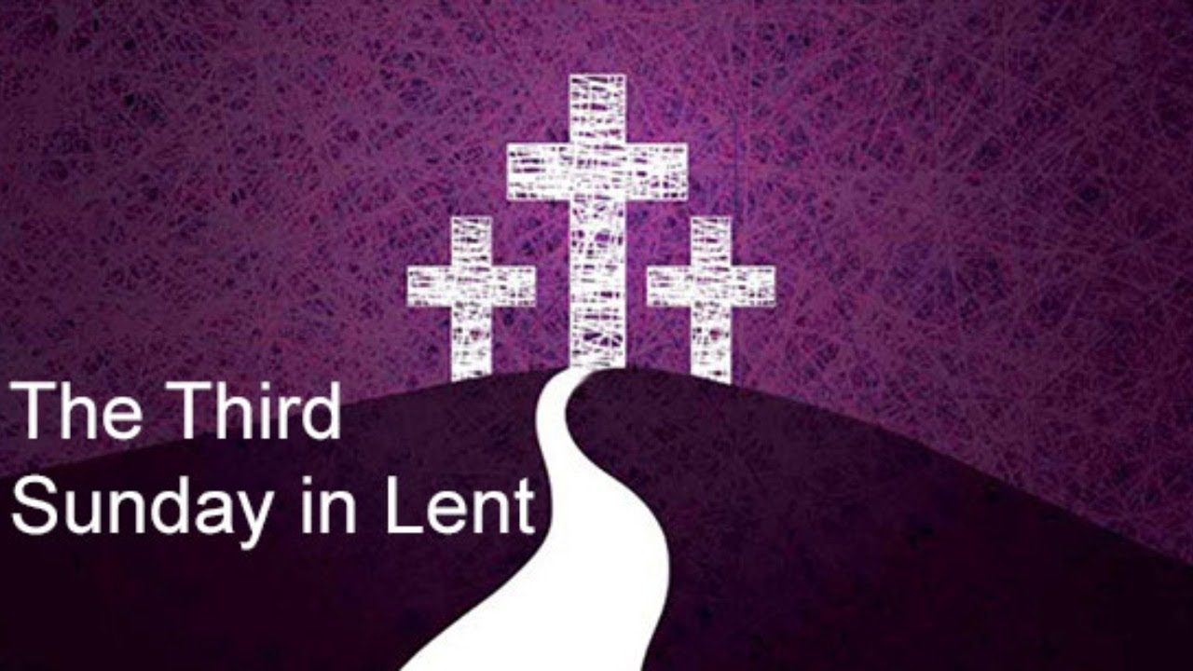

Minister
Rev Bill Jackson

Organist
Mr Alex Ferguson

