The vision of the Church of Scotland is to be a church which seeks to inspire the people of Scotland and beyond with the Good News of Jesus Christ through enthusiastic, worshipping, witnessing, nurturing and serving communities.

Entry of the Bible
(we stand as the Bible is brought into church)
Introit

Welcome - Grace & Call to Worship

Lighting of Advent Candle

Praise 175 Praise, I will praise you Lord

Prayer of Approach and Lord’s Prayer

DEDICATION OF GIFTS/TOYS
Praise MP 42 At this time of giving

Bible Reading Isaiah chapter 12 v 1 – 6 (pg 698)
(Linda Wallace)

Anthem
REFLECTION ON GOD’S WORD

Praise CH4 543 Longing for light

Prayers of Thanksgiving and for others

Praise CH4 277 Hark the Glad Sound!
(Credition)

Benediction

Notices

A warm welcome is extended to everyone this morning and especially to any visitors worshipping with us today.

Please take a few minutes to read the screens as there may be information, which was received too late for the printed intimations.

Our minister, the Rev. Fiona Maxwell, can be contacted by telephone on 01563 521762, by mobile on 07507 312123 or by email, FMaxwell@churchofscotland.org.uk

The email address for the Church Administrator is kppcchurchoffice@gmail.com or phone 07394 173977. Please note the new email address for the church administrator.

If you are watching the service via live stream the digital order of service is available on the church website under the services page.

There is now creche and young church facilities in the side chapel, if you have children with you, please use this room as and when you need to.

Tea/coffee will be served after morning worship, please come down to the hall for a warm cuppa and even warmer chat and fellowship.

The Guild meets on Tuesday 5 December at 2pm for an afternoon with the Von Crapp Singers. All welcome.

Wednesday Walkers meet at the Kay Park at 10am at the top car park near the Burns Centre, enjoy a walk round the park and a good chat and then have coffee/tea in the church café. All welcome.

Wednesday café is open every Wednesday morning from 10am – 12 noon. Please tell your friends and neighbours and come and enjoy the company and chat.

Joint Walk on Saturday 9th December will be based around the Dean Castle Country Park. Walkers should assemble for 10am in the main car park off of Dean Road. Route will be chosen on the day depending on conditions. Post-walk refreshments will be in the park cafe.
Foodbank- Items can still be left at the back of the church in the wicker basket, these items are then taken to the Salvation Army for their foodbank, supplies are required urgently, so please give generously.

New to Kay Park?
If you are new to Kay Park, please feel free to approach the Minister, Rev Fiona on (01536) 521762 or the Session Clerk, Janette Steven, (01563) 401209, for further information about the Church and Membership. If you would like information about giving to the church financially, please contact the Treasurer, Alex Steven on 01563 401209

Giant Church Christmas Card
In the past years we had a Giant Christmas Card that you could sign rather than handing out cards to each other on a Sunday morning. In turn people gave a donation in liu to the work of Christian Aid. This has not worked so well over the last couple of years so we are not going to have the Giant Card this year but will consider something similar for 2024. Ideas welcome!

Many hands!
There are times in the church year, December being one of them, when the Sanctuary is used for large concerts/events. It is great to host these gatherings but is a lot of work in terms of setting and resetting the chairs etc. If you would be willing to give some time (likely, 30 mins or so after an event) to help tidy and set things up again can you please give your name to Vanessa. email, kppcchurchoffice@gmail.com Thank you!

Blue Christmas
This year we have a table next to the side chapel laid out with a tree and blue labels, you can write the name of a loved one, whom you would like to be remembered, on a label and hang it on the tree.

www.kayparkparishchurch.org.uk
(Registered Scottish Charity: SC008154)

Sunday 3 December 2023

FIRST SUNDAY IN ADVENT

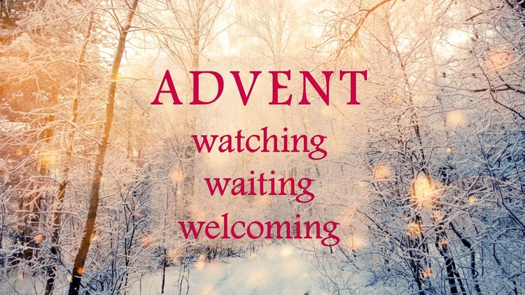

Minister
Rev. Fiona Maxwell

Organist
Mr Alex Ferguson

