The vision of the Church of Scotland is to be a church which seeks to inspire the people of Scotland and beyond with the Good News of Jesus Christ through enthusiastic, worshipping, witnessing, nurturing and serving communities.

Entry of the Bible
(We stand as the Bible is brought into church)
Choir: Creation sings the Father’s song)

Introit: I watch the sunrise…
Welcome – Grace & Call to Worship

Praise 715 Behold! the mountain of the Lord in
latter days shall rise…
Prayer of Approach & Lord’s Prayer

Reflection: Blythswood Care Shoe Box Appeal Dedication

Praise 709 The right hand of God is writing in our land,

Bible Reading St. Matthew 22: 34-46 (pg 991)
(Shiona Thomson)

Anthem: “The Prayer/Lead me Lord”

Praise 259 Beauty for brokenness, hope for despair,

Reflection on God’s Word: “All You Need Is Love.”

Praise 198 Let us build a house where love can
dwell and all can safely live,

Prayer of Thanks and Intercession
Praise 360 Jesus Christ is waiting, waiting in the streets;

Benediction

Notices
A warm welcome is extended to everyone this morning and especially to any visitors worshipping with us today.

Please take a few minutes to read the screens as there may be information, which was received too late for the printed intimations.

Our minister, the Rev. Fiona Maxwell, can be contacted by telephone on 01563 521762, by mobile on 07507 312123 or by email, FMaxwell@churchofscotland.org.uk

The Minister will not be available from Friday 27 October to Wednesday 1st. Please contact the Session Clerk if you have any pastoral concerns or questions.

The email address for the Church Administrator is kppcchurchoffice@gmail.com or phone 07394 173977. Please note the new email address for the church administrator.

If you are watching the service via live stream the digital order of service is available on the church website under the services page.

There is now creche and young church facilities in the side chapel, if you have children with you, please use this room as and when you need to.

Tea/coffee will be served after morning worship, please come down to the hall for a warm cuppa and even warmer chat and fellowship.

Mrs Grace Scott of 8 Rugby Cresent died this week. Grace's funeral is to take place in Kay Park on Thursday, 9 November at 11.30 followed by a service in Holmsford Bridge at 12.30.

The Guild will meet on Tuesday 31 October at 2pm in the Church Hall for a talk on the Guild Project – Star Child. This project has connections to Tanker Hall Children’s Home. This event is being filmed so a good turnout of members and visitors would be great.

Wednesday Walkers meet at the Kay Park at 10am at the top car park near the Burns Centre, enjoy a walk round the park and a good chat and then have coffee/tea in the church café. All welcome.

Wednesday café is open every Wednesday morning from 10am – 12 noon. Please tell your friends and neighbours and come and enjoy the company and chat.

Friendship Club meet on 2 November at 2pm when the speaker will be Rev Jill Clancy – Life as a Prison Chaplain. All Welcome

Strollers' walk will be on Friday 3rd November. Assemble for 10am at the garden centre at Rouken Glen Park, Glen Road, Glasgow. Post code G46 7JL. The walk will be around the paths within the park with refreshments afterwards in the garden centre cafe.

Communion will be celebrated as part of worship on Sunday 5 November. Elders should meet in the halls at 10.30am

SHOEBOX APPEAL
Thank you to all of you who have donated to the above appeal. If you have forgotten to bring your shoebox today don’t panic. There is still time - bring your box along next Sunday.

The Fellowship of Kilmarnock Churches newsletter for October is available on the Communion Table as you come into church.

Foodbank- Items can still be left at the back of the church in the wicker basket, these items are then taken to the Salvation Army for their foodbank, supplies are required urgently, so please give generously.

New to Kay Park?
If you are new to Kay Park, please feel free to approach the Minister, Rev Fiona on (01536) 521762 or the Session Clerk, Janette Steven, (01563) 401209, for further information about the Church and Membership. If you would like information about giving to the church financially, please contact the Treasurer, Alex Steven on 01563 401209

www.kayparkparishchurch.org.uk
(Registered Scottish Charity: SC008154)

29th. October 2023
22nd. after Pentecost

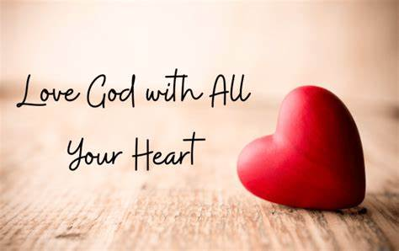

Minister
Rev. Bill Jackson

Organist
Mr. Alex Ferguson

