The vision of the Church of Scotland is to be a church which seeks to inspire the people of Scotland and beyond with the Good News of Jesus Christ through enthusiastic, worshipping, witnessing, nurturing and serving communities.

Entry of the Bible
(we stand as the Bible is brought into church)

Grace & Call to Worship

Praise 210 Awake my Soul

Prayer of Approach and Lord’s Prayer

Chat for All

Praise 180 Give Thanks with a grateful heart

Bible Reading Psalm 77: 1 -2, 11 – 20 (pg 589)
Luke 9: 51 – 62 (pg 1040)
(Elaine MacPherson)

Praise 599 Holy Spirit, hear us

REFLECTION - Choices

Praise 532 Lord, you have come to the seashore

Prayers of Thanksgiving and for others

Praise 644 O Jesus, I have promised

Benediction

Notices

A warm welcome is extended to everyone this morning and especially to any visitors worshipping with us today.

Please take a few minutes to read the screens as there may be information, which was received too late for the printed intimations.

Our minister, the Rev. Fiona Maxwell, can be contacted by telephone on 01563 521762, or by email, FMaxwell@churchofscotland.org.uk

The email address for the Church Administrator is kppcchurchoffice@gmail.com or phone 07394 173977.

If you are watching the service via live stream the digital order of service is available on the church website under the services page.

Reminder If you have a hearing device, please make sure you have put it to the ‘T‘ position to enable it to link up with the church loop system.

Tea/coffee will be served after morning worship, please come down to the hall for a warm cuppa and even warmer chat and fellowship.

Wednesday Walkers meet at the Kay Park at 10am at the top car park near the Burns Centre, enjoy a walk round the park and a good chat and then have coffee/tea in the church café. All welcome.

Wednesday café 10am – 12 noon. The café is now serving toast and cup-a-soup. Please tell your friends and neighbours and come and enjoy the company and chat.

Friendship Club meet on Thursday 3 July at 2pm in the café area of the church for coffee and a chat. Enter by the main front door.

Foodbank- Items can still be left at the back of the church in the wicker basket, these items are then taken to the Salvation Army for their foodbank, supplies are required urgently, so please give generously.

New to Kay Park?
If you are new to Kay Park, please feel free to approach the Minister, Rev Fiona on (01563) 521762 or the Session Clerk, Jean Johnston, 07944 891078, for further information about the Church and Membership. If you would like information about giving to the church financially, please contact the Treasurer, Gordon Slater 07768 780051
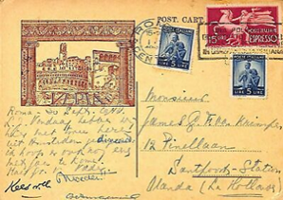
Postcards from around the Globe
If you’re away for a holiday or just a day trip then either send us a postcard or bring one back and put it in the post box at the back of the church. Kay Park Parish Church, London Road, Kilmarnock, KA3 7AA

Advance Notice
Evening Walks – Walk & Talk each walk will take approximately 1hr
Wednesday 23 July – 7pm Dean Castle Country Park
Thursday 28 August – 7pm Irvine Harbourside

The latest Edition of the Church Newsbite is available at the back of the church or as you go out of the back door into the car park.


www.kayparkparishchurch.org.uk
(Registered Scottish Charity: SC008154)

Sunday 29 June 2025

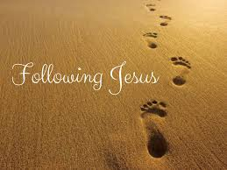

Minister
Rev. Bill Hewitt

Organist
Mr Charles Donnelly

