Entry of the Bible (we stand as the Bible is brought into church)

Grace and Call to Worship

Praise The Harvest Table (we stand as gifts are brought forward)

Harvest Prayer and Lord’s Prayer

Praise Creation Sings

YOUNG CHURCH – Harvest Presentation
(including the Harvest Samba)

Bible Reading Luke chapter 12 v 16 – 30 (pg 1044)
(Olive Caldwell)

Praise GWA 153 God, the Maker of the heavens

REFLECTION ON GOD’S WORD

Anthem

Prayers of Thanksgiving and for others

Praise 229 We plough the fields and scatter

Benediction

Notices

A warm welcome is extended to everyone this morning and especially to any visitors worshipping with us today.

Please take a few minutes to read the screens as there may be information, which was received too late for the printed intimations.

Our minister, the Rev. Fiona Maxwell, can be contacted by telephone on 01563 521762, or by email, FMaxwell@churchofscotland.org.uk

The email address for the Church Administrator is kppcchurchoffice@gmail.com or phone 07394 173977.

If you are watching the service via live stream the digital order of service is available on the church website under the services page.

Reminder If you have a hearing device, please make sure you have put it to the ‘T‘ position to enable it to link up with the church loop system.

Tea/coffee will be served after morning worship, please come down to the hall for a warm cuppa and even warmer chat and fellowship.

Fellowship of Kilmarnock Churches – All one in Christ Jesus celebrating the talents of all God’s family. Today Sunday 28 September at 3pm in St Marnocks Church.

Our friends at New Laigh Kirk invite us to join with them for 'Church Unplugged'. Sunday 28 September 6.30 – 7.30 in New Laigh Kirk Church.

Guild will meet on Tuesday 30 September at 2pm in the Church Hall for coffee & chat.

Wednesday Walkers meet at the Kay Park at 10am at the top car park near the Burns Centre, enjoy a walk round the park and a good chat. All welcome.

Friendship Club meet on Thursday 2 October at 2pm when the speaker will be Rev Fiona Maxwell. All welcome.

Praise & Worship Evening: John Knox Praise Band invites you to an evening of praise & worship with fellowship and refreshments on Fri 3rd Oct, 7.30pm (doors open 7pm) at John Knox church, Stewarton

Crossreach Christmas cards - Jean Herbert will be in the hall taking orders over the next 3 weeks.

Foodbank- Items can still be left at the back of the church in the wicker basket, these items are then taken to the Salvation Army for their foodbank, supplies are required urgently, so please give generously.

New to Kay Park?
If you are new to Kay Park, please feel free to approach the Minister, Rev Fiona on (01563) 521762 or the Session Clerk, Jean Johnston, 07944 891078, for further information about the Church and Membership. If you would like information about giving to the church financially, please contact the Treasurer, Gordon Slater 07768 780051

Stamps If you are one of the few people who still gets letters with stamps we are looking for your stamps. There will be a box in the café area for you to put them, these will then be trimmed and sent away to Embrace the Middle East or Mercy Ships.

Church Outing June 13/14 2026. Going to Alnwick & staying at the White Swan Hotel in Alnwick on Sat 13 June. Sunday 14 June Sunday service on Lindisfarne, coming home via the Borders and having high tea at the Tontine Hotel in Peebles.
Cost PP if sharing a room £160
If single room/occupancy £198
If interested, please confirm with Janette Steven 07788 298355
Alex Steven will be running a bank if people wish to pay up on a weekly or monthly basis.

Blythswood Shoebox Appeal
I hope you are managing to fill your shoeboxes for Blythswood Care. Leaflets giving more information are available at the rear of the church. A leaflet needs to accompany each box. Boxes should be brought to church the last Sunday in October. You can also sponsor a shoebox by visiting https://blythswood.org/sponsor-a-shoebox/


www.kayparkparishchurch.org.uk
(Registered Scottish Charity: SC008154)

Sunday 28 September 2025

HARVEST THANKSGIVING

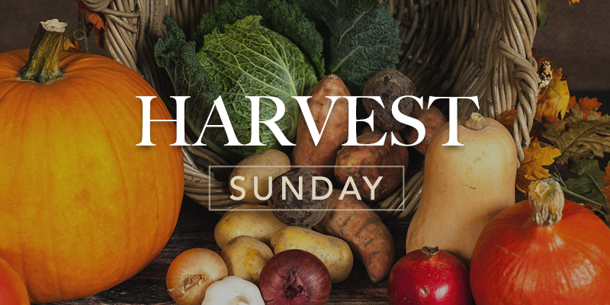

Minister
Rev Fiona Maxwell

Musicians
Stacey Connell,
Alex Ferguson,
Grant Donald

