The vision of the Church of Scotland is to be a church which seeks to inspire the people of Scotland and beyond with the Good News of Jesus Christ through enthusiastic, worshipping, witnessing, nurturing and serving communities.

Entry of the Bible

Introit

Welcome - Grace & Call to Worship

Praise CH4189 Be still for the presence of the Lord

Prayer of Approach and Lord’s Prayer

CHAT FOR ALL
Praise CH4 359 He came down that we might have love

Bible Reading Mark ch 1 v 21 -28 (pg 1002)
(Elizabeth Templeton)

Praise CH4 722 Spirit of God come dwell within me

REFLECTION ON GOD’S WORD
Anthem

Prayers of Thanksgiving and for others

Praise CH4 348 Praise the One who breaks the darkness

Benediction

Notices

A warm welcome is extended to everyone this morning and especially to any visitors worshipping with us today.

Please take a few minutes to read the screens as there may be information, which was received too late for the printed intimations.

Our minister, the Rev. Fiona Maxwell, can be contacted by telephone on 01563 521762, by mobile on 07507 312123 or by email, FMaxwell@churchofscotland.org.uk

The email address for the Church Administrator is kppcchurchoffice@gmail.com or phone 07394 173977. Please note the new email address for the church administrator.

If you are watching the service via live stream the digital order of service is available on the church website under the services page.

There is now creche and young church facilities in the side chapel, if you have children with you, please use this room as and when you need to.

Tea/coffee will be served after morning worship, please come down to the hall for a warm cuppa and even warmer chat and fellowship.

The Guild meet on Tuesday 30 January at 2pm for Burns poems & music by John Hodgart. All welcome.

Wednesday Walkers meet at the Kay Park at 10am at the top car park near the Burns Centre, enjoy a walk round the park and a good chat and then have coffee/tea in the church café. All welcome.

Wednesday café is open every Wednesday morning from 10am – 12 noon. Please tell your friends and neighbours and come and enjoy the company and chat.
At the café on Wednesday there will be a Health Development Officer from Vibrant Communities offering health checks from 10.30 – 11.30.

Sunday, 4 February we will share together in the bread and wine of Communion as part of our worship. Young Church will meet for 1st Sunday in the hall.

Sunday, 4 February, Children & Church. There will be a meeting of all those interested in being involved with and supporting the work we do with children. Please meet in the top part of the downstairs hall at 12.15pm. Bring a packed lunch, tea/coffee and something sweet will be provided. After we have eaten there will be a wee team led by Olive Caldwell who will look after your small people whilst we chat and share ideas.

Thursday, 8 February, 2pm: "Supporting People on the Move", Fiona Kendall, Mission Partner
Fiona Kendall, who is a Church of Scotland Mission Partner with the Mediterranean Hope project, will be the guest speaker at a meeting of the Friendship Club of Kay Park Church on Thursday, 8 February, at 2 p.m. An invitation is extended to everyone, male and female of any age who is concerned about the plight of migrants who risk the dangerous passage across the Mediterranean Sea in overcrowded boats.

Welcome Lunch, if you are new to Kay Park Church you are invited to a welcome lunch on Sunday 11 February at 12.45 after morning coffee. Please give your names to Janette Steven 01563 401209 janettesteven12k@gmail.com by 4 February. Thank you

Lent begins this year on Wednesday, 14 February.
We will have an Ash Wednesday Service at 7pm on Wednesday, 14th.
Then on the 6th, 13th and 20th March, "FAITH STORIES" returns to the Church cafe area for three weeks, meeting at 7pm.

Foodbank- Items can still be left at the back of the church in the wicker basket, these items are then taken to the Salvation Army for their foodbank, supplies are required urgently, so please give generously.

New to Kay Park?
If you are new to Kay Park, please feel free to approach the Minister, Rev Fiona on (01536) 521762 or the Session Clerk, Janette Steven, (01563) 401209, for further information about the Church and Membership. If you would like information about giving to the church financially, please contact the Treasurer, Alex Steven on 01563 401209

www.kayparkparishchurch.org.uk
(Registered Scottish Charity: SC008154)

Sunday 28 January 2024
Epiphany 4

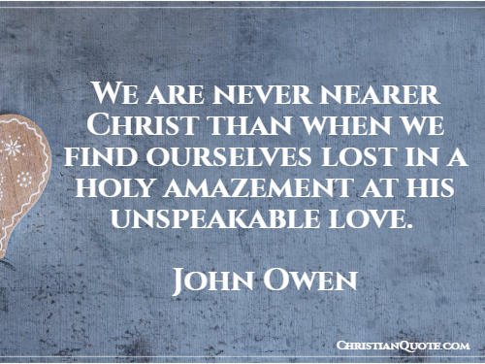
(John Owen was a 17th Century Church Leader)

Minister
Rev. Fiona Maxwell

Organist
Mr Alex Ferguson

