The vision of the Church of Scotland is to be a church which seeks to inspire the people of Scotland and beyond with the Good News of Jesus Christ through enthusiastic, worshipping, witnessing, nurturing and serving communities.

Entry of the Bible
(we stand as the Bible is brought into church)
Introit

Grace & Call to Worship

Praise 185 Come children join and sing

Prayer of Approach and Lord’s Prayer

CHAT for ALL

Praise 194 This is the day

Bible Reading Acts chapter 8 v 26 – 40 (pg 1101)
(Morag Lindsay)

Praise 755 Be still and know

REFLECTION ON GOD’S WORD

Praise 719 The one who longs to make us whole
(Tune: Kingsfold)

Prayers of Thanksgiving and for others

Praise 198 Let us build a house (Omit v3)

Benediction

Notices

A warm welcome is extended to everyone this morning and especially to any visitors worshipping with us today.

Please take a few minutes to read the screens as there may be information, which was received too late for the printed intimations.

Our minister, the Rev. Fiona Maxwell, can be contacted by telephone on 01563 521762, or by email, FMaxwell@churchofscotland.org.uk

The email address for the Church Administrator is kppcchurchoffice@gmail.com or phone 07394 173977. Please note the new email address for the church administrator.

If you are watching the service via live stream the digital order of service is available on the church website under the services page.

Tea/coffee will be served after morning worship, please come down to the hall for a warm cuppa and even warmer chat and fellowship.

Guild meet for coffee and chat on Tuesday 30 April at 2pm in the café area.

Wednesday Walkers meet at the Kay Park at 10am at the top car park near the Burns Centre, enjoy a walk round the park and a good chat and then have coffee/tea in the church café. All welcome.

Wednesday café is open every Wednesday morning from 10am – 12 noon. Please tell your friends and neighbours and come and enjoy the company and chat.

Friendship Hour on Thursday 2 May at 2pm in the main hall when a Beetle Drive is planned and everyone is welcome.

Christian Aid Concert Thursday 2 May at 7.30pm in New Laigh Kirk, tickets are not required but a donation to Christian Aid would be appreciated.

The next Strollers' walk will be on Friday 3rd May. Assemble, for 10am, in the car park opposite the Barr Castle in Galston. Post code KA4 8HU.

Christian Aid Quiz Night Friday 17 May 7pm tickets are free of charge, please plan to give a donation to Christian Aid on the night, light refreshments will be provided. Tickets available from Jean Deans, Jeff Davies & Vanessa Twomey.

The Fellowship of Kilmarnock Churches Newsletter is available at the back of the Church.

Foodbank- Items can still be left at the back of the church in the wicker basket, these items are then taken to the Salvation Army for their foodbank, supplies are required urgently, so please give generously.

New to Kay Park?
If you are new to Kay Park, please feel free to approach the Minister, Rev Fiona on (01563) 521762 or the Session Clerk, Janette Steven, (01563) 401209, for further information about the Church and Membership. If you would like information about giving to the church financially, please contact the Treasurer, Alex Steven on 01563 401209

www.kayparkparishchurch.org.uk
(Registered Scottish Charity: SC008154)

EASTER 5
Sunday 28 April 2024

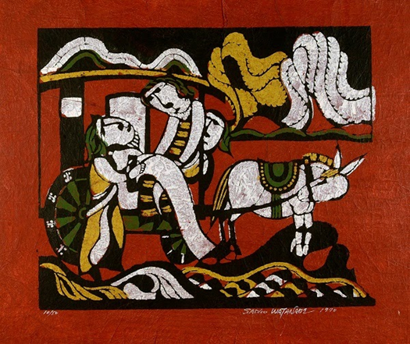

Minister
Rev. Fiona Maxwell

Organist
Mr Alex Ferguson

