The vision of the Church of Scotland is to be a church which seeks to inspire the people of Scotland and beyond with the Good News of Jesus Christ through enthusiastic, worshipping, witnessing, nurturing and serving communities.

Entry of the Bible (we stand as the Bible is brought into church)

Song “Harvest Table” (YC & Choir)

Grace and Call to Worship

Praise 229 We plough the fields and scatter

Prayer of Approach and Lord’s Prayer

Dedication of the Harvest Gifts

Song Our God is an Awesome God (YC & Choir)

Bible Reading Exodus ch 16: 2 - 15 (pg 73)
(Aileen Sansum)

Praise 231 For the fruits of all creation
(Tune: Ar Hyd Y Nos))

Reflection on God’s Word

Praise 180 Give thanks with a grateful heart

Prayers of Thanksgiving and for others

Praise GWA 154 God, the maker of the heavens
(Tune: Converse)

Benediction

Notices

A warm welcome is extended to everyone this morning and especially to any visitors worshipping with us today.

Please take a few minutes to read the screens as there may be information, which was received too late for the printed intimations.

Our minister, the Rev. Fiona Maxwell, can be contacted by telephone on 01563 521762, or by email, FMaxwell@churchofscotland.org.uk

The email address for the Church Administrator is kppcchurchoffice@gmail.com or phone 07394 173977.

If you are watching the service via live stream the digital order of service is available on the church website under the services page.

Reminder If you have a hearing device, please make sure you have put it to the ‘T‘ position to enable it to link up with the church loop system.

Tea/coffee will be served after morning worship, please come down to the hall for a warm cuppa and even warmer chat and fellowship.

Wednesday Walkers meet at the Kay Park at 10am at the top car park near the Burns Centre, enjoy a walk round the park and a good chat. All welcome.

Wednesday Café 10am – 12 noon all welcome for a cuppa and chat.

Friendship Club meet on Thursday 1 October at 2pm in the hall for their opening meeting, todays speaker is Rev Fiona Maxwell. All Welcome

Praise Night at John Knox Stewarton will be Sunday evening 4th October and will led by Christina and Kyle Cordner along with our Youth. Please come and join with us in an evening of informal and contemporary worship, meditations and quiet reflection, food and fellowship. Doors open 6.45 when refreshments are served.

Advance Notice Fundraising Concert Kilmarnock Aeolian Choir Friday 23 October 7.30pm in Kay Park Church. Tickets £8 all proceeds going to Kyle Oncology Unit, Ailsa hospital.

Foodbank- Items can still be left at the back of the church in the wicker basket, these items are then taken to the Salvation Army for their foodbank, supplies are required urgently, so please give generously.

New to Kay Park?
If you are new to Kay Park, please feel free to approach the Minister, Rev Fiona on (01563) 521762 or the Session Clerk, Jean Johnston, 07944 891078, for further information about the Church and Membership. If you would like information about giving to the church financially, please contact the Treasurer, Gordon Slater 07768 780051

Stamps If you are one of the few people who still gets letters with stamps we are looking for your stamps. There will be a box in the café area for you to put them, these will then be trimmed and sent away to Embrace the Middle East or Mercy Ships.


www.kayparkparishchurch.org.uk
(Registered Scottish Charity: SC008154

Harvest Thanksgiving
Sunday 27 September 2026

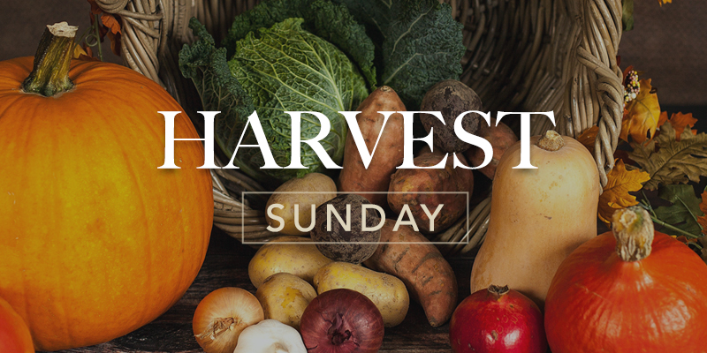

Minister
Rev Fiona Maxwell

Organist
Stacey Connell

