The vision of the Church of Scotland is to be a church which seeks to inspire the people of Scotland and beyond with the Good News of Jesus Christ through enthusiastic, worshipping, witnessing, nurturing and serving communities.

Entry of the Bible
(we stand as the Bible is brought into church)

Welcome and Notices

Grace & Call to Worship

Praise CH4 113 God the Father of Creation

Prayer of Approach and the Lord’s Prayer

Little Thoughts for the Day

Praise CH4 530 One more step along the road I go

Bible Reading Philippians Ch 1:12 – 30 (pg 1178)
(Moira Graham)
Praise CH4 550 As the deer pants for the water

Address: The way to live, a way of life

Praise CH4 543 Christ be our Light
Prayers of Thanksgiving and for Others

Praise CH4 458 At the Name of Jesus

Benediction

Notices
A warm welcome is extended to everyone this morning and especially to any visitors worshipping with us today.

Please take a few minutes to read the screens as there may be information, which was received too late for the printed intimations.

We welcome Rev Taylor Brown to lead our worship this morning as Rev Fiona leads the closing service at St John's Onthank.

Rev Fiona is on annual leave from Monday 28 August to Tuesday 12 September. During this time please emergency pastoral cover will be provided by the Rev Bill Jackson, 07752 549308. For any other matters please contact the Session Clerk, Janette Steven 07788 298355.

We look forward to welcoming Rev Bill Jackson to lead our worship on Sunday, 3 September and Sunday 10 September.

The email address for the Church Administrator is kppcchurchoffice@gmail.com or phone 07394 173977. Please note the new email address for the church administrator.

If you are watching the service via live stream the digital order of service is available on the church website under the services page.

There is now creche and young church facilities in the side chapel, if you have children with you, please use this room as and when you need to.

Tea/coffee will be served after morning worship, please come down to the hall for a warm cuppa and even warmer chat and fellowship.

Fellowship of Kilmarnock Churches meet today Sunday 27 August 3pm in St Kentigern’s Church – Celebration of the World Church, discover how local Christians are connecting with the worldwide Church.

The Guild meet on Tuesday 29 August for coffee & chat in the café area of the church at 2pm. Please enter by the main door. All welcome.

Wednesday Walkers meet at the Kay Park at 10am at the top car park near the Burns Centre, enjoy a walk round the park and a good chat and then have coffee/tea in the church café. All welcome.

Wednesday café is open every Wednesday morning from 10am – 12 noon. Please tell your friends and neighbours and come and enjoy the company and chat.

Communion Sunday 3 September at 11am led by Rev Bill Jackson.

Organ Recital on Tuesday 8th September at 12noon in St Joseph’s RC Church.

Irvine and Kilmarnock Guilds Together plan to live-stream The Annual Gathering from Edinburgh on 9th September to the Howard Centre, Kilmarnock, starting at 11.00 a.m. Lunch break will be from 12.45 – 2.00 p.m. You may wish to bring a packed lunch as tea and coffee will be available. The event should end about 4.00 p.m. but you are free to come and go at any time. This is an opportunity to experience this annual event in the company of fellow Guild members at a local venue. Plus, you will be able to witness Rae Lind of Newmilns Guild being installed by her husband, Rev. George Lind, as the new National Convener.

DOORS OPEN DAY Kay Park will once again be opening our doors to the public on Saturday 9th September from 10.00 am until 2.00 pm as part of Doors Open Day 2023.

Reachout Together Disability Inclusion Project invites everyone to a Disability Sunday afternoon service at 3.30 p.m. on 17th September in St Marnock's Church halls. The entrance to the halls is at the side of the church.

Women’s Day Reconnecting Mauchline Parish Church on Saturday 30 September from 9.30am – 2.30pm cost £10 inc. lunch. Please give your name to Vanessa Twomey the Church administrator if you are interested in going.

Welcoming Team
The welcoming team are an important part of Sunday morning worship. We urgently need new volunteers to join the team so if you are willing to be on once every 8 weeks, please speak to Janette Steven. The duties include welcoming people as they arrive and then being at the door at the end of worship to see people on their way.

Foodbank- Items can still be left at the back of the church in the wicker basket, these items are then taken to the Salvation Army for their foodbank, supplies are required urgently, so please give generously.

www.kayparkparishchurch.org.uk
(Registered Scottish Charity: SC008154)

27 August 2023
13th Sunday after Pentecost

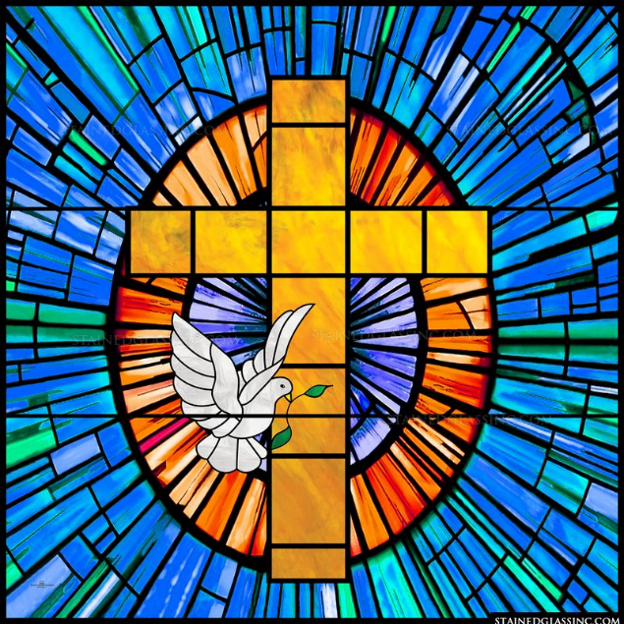

Minister
Rev. Taylor Brown

Organist
Mr Alex Ferguson

