The vision of the Church of Scotland is to be a church which seeks to inspire the people of Scotland and beyond with the Good News of Jesus Christ through enthusiastic, worshipping, witnessing, nurturing and serving communities.

Entry of the Bible
(we stand as the Bible is brought into church)
Introit

Welcome - Grace & Call to Worship

Praise 356 Meekness and Majesty

Prayer of Approach and Lord’s Prayer

SACRAMENT OF BAPTISM
Including The Lord Bless you and Keep you CH4 796

Praise 633 Child of Blessing (Tune: Servant Song)

Bible Reading Psalm 95 v 1 – 7 (pg 602)
(Billy Moore)

Praise 462 The King of Love my Shepherd is

REFLECTION ON GOD’S WORD
Anthem

Prayers of Thanksgiving and for others

Praise 470 Jesus shall reign where’er the sun

Benediction

Notices

A warm welcome is extended to everyone this morning and especially to any visitors worshipping with us today.

Please take a few minutes to read the screens as there may be information, which was received too late for the printed intimations.

Our minister, the Rev. Fiona Maxwell, can be contacted by telephone on 01563 521762, by mobile on 07507 312123 or by email, FMaxwell@churchofscotland.org.uk

The email address for the Church Administrator is kppcchurchoffice@gmail.com or phone 07394 173977. Please note the new email address for the church administrator.

If you are watching the service via live stream the digital order of service is available on the church website under the services page.

There is now creche and young church facilities in the side chapel, if you have children with you, please use this room as and when you need to.

Tea/coffee will be served after morning worship, please come down to the hall for a warm cuppa and even warmer chat and fellowship.

A huge thank you to all who gave so generously to the retiring offering last Sunday, a total of £473 was raised for Christian Aid.

Wednesday Walkers meet at the Kay Park at 10am at the top car park near the Burns Centre, enjoy a walk round the park and a good chat and then have coffee/tea in the church café. All welcome.

Wednesday café is open every Wednesday morning from 10am – 12 noon. Please tell your friends and neighbours and come and enjoy the company and chat.

Kirk Session will meet on Wednesday 29 November in the church hall at 7pm.

Friendship Club meet on Thursday 30 November at 2pm for the Christmas Stall & Quiz afternoon. All welcome.

The Church Christmas Lunch is on Sunday 3 December at 12.15, tickets for this event will be available at the church office today. Suggested donation of £5.

Toy Service is on Sunday 3 December, please plan to bring a gift for a child/teenager, boy or girl on this day. The gift should not be wrapped, and these will be taken to the Salvation Army for distribution. Thank you.

An invitation is extended to you from St Kentigern's Church to join them at their annual ceilidh, on Saturday 2 December, which was enjoyed last year by almost 100 people. There will be hot food at 6.30 pm, followed by the ceilidh which will include games for children. The evening will end at 9 pm. There is no charge, but you can make a donation if you want. Can you please let Bill Caldwell or Jeff Davies know today if you would like to go as they need numbers for catering purposes.

Foodbank- Items can still be left at the back of the church in the wicker basket, these items are then taken to the Salvation Army for their foodbank, supplies are required urgently, so please give generously.

New to Kay Park?
If you are new to Kay Park, please feel free to approach the Minister, Rev Fiona on (01536) 521762 or the Session Clerk, Janette Steven, (01563) 401209, for further information about the Church and Membership. If you would like information about giving to the church financially, please contact the Treasurer, Alex Steven on 01563 401209

www.kayparkparishchurch.org.uk
(Registered Scottish Charity: SC008154)

Sunday 26 November 2023

SUNDAY BEFORE ADVENT – CHRIST THE KING

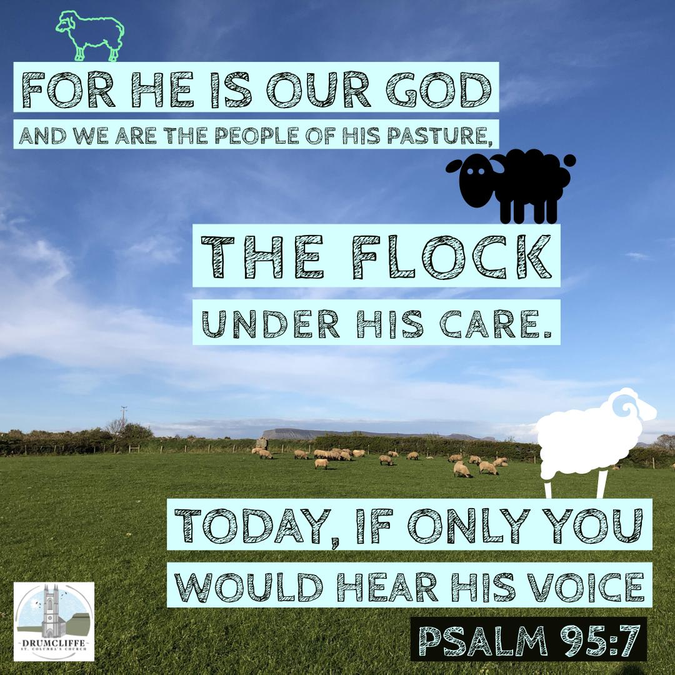

Minister
Rev. Fiona Maxwell

Organist
Mr Alex Ferguson

