The vision of the Church of Scotland is to be a church which seeks to inspire the people of Scotland and beyond with the Good News of Jesus Christ through enthusiastic, worshipping, witnessing, nurturing and serving communities.

Entry of the Bible
(we stand as the Bible is brought into church)

Welcome and Notices

Introit

Grace & Call to Worship

Praise 189 Be still for the presence of the Lord

Prayer of Approach and the Lord’s Prayer

Chat to All

Praise God’s Love is deeper

Bible Reading John chapter 11 v 21 -27; 32 – 44 (Pg1078)
(Olive Gow)

Praise 726 When are living we are in the Lord

Reflection on God’s Word

Video O Love that wilt not let me go (Elaine Hagenburg)

Prayers of Thanksgiving & for Others

Praise 462 The King of Love my shepherd is

Benediction

Notices
A warm welcome is extended to everyone this morning and especially to any visitors worshipping with us today.

Please take a few minutes to read the screens as there may be information, which was received too late for the printed intimations.

Our minister, the Rev. Fiona Maxwell, can be contacted by telephone on 01563 521762, by mobile on 07507 312123 or by email, FMaxwell@churchofscotland.org.uk

The email address for the Church Administrator is chrchdmnstr@outlook.com. or phone 07394 173977

If you are watching the service via live stream the digital order of service is available on the church website under the services page.

There is now creche and young church facilities in the side chapel, if you have children with you, please use this room as and when you need to.

Tea/coffee will be served after morning worship, please come down to the hall for a warm cuppa and even warmer chat and fellowship.

Scalliwags meet Monday at 9.30am – 11am. The group is for all children under 3 and should be accompanied by an adult.

Brownies & Guides 17th Kilmarnock Brownies and 6th Kilmarnock Guides will meet in the church halls on Monday at 6pm and 7.30pm.

Wednesday café is open every Wednesday morning from 10am – 12 noon. Please tell your friends and neighbours and come and enjoy the company and chat.

Lent Faith Stories meet on Wednesday March 29 at 7pm in the church café, please enter by front door. All welcome.

Foodbank- Items can still be left at the back of the church in the wicker basket, these items are then taken to the Salvation Army for their foodbank, supplies are required urgently, so please give generously.
Some items that are often forgotten are: Tin Openers, Toiletries, Toilet Rolls, Detergent/washing up liquid, Nappies and other baby supplies, Free from all items e.g Gluten Free

EACHa the drop-in is open in the New Laigh Kirk hall between 1pm and 3pm on Mondays and Wednesdays. We hope to also open on Fridays and would be delighted to hear from anyone who can spare an hour or two to volunteer with us.

Christian Aid Family Friendly Quiz in the church hall on Saturday 13 May at 2pm. It will be open to those aged 5 and over, and everyone must have a ticket. These will be free of charge, but a donation towards Christian Aid will be requested. Tickets will be available from Sunday 16 April from Bill Caldwell, Jeff Davies, Moira Graham, Jean Deans and Bobby Goudie.

The Howard Centre will be open as a 24/7 Prayer Room throughout Holy Week running from Sunday 2nd – Saturday 8th April.
We will have a whole variety of Prayer Spaces and activities for you to access, these spaces will be suitable for children & adults of all ages.
Please see below the link which will take you straight to the sign-up page (please use your email address when signing up as this will allow us to send you appropriate materials)
https://signup.24-7prayer.com/signup/610933
You can also sign up by simply contacting Elaine Wardrop by phone or email using the details below and giving your preferred slot and she can book for you.
Our 24/7 Prayer Room will once again be a mix of in-person prayer or pray from home.
The commitment is simply to book and agree to pray through your slot, each slot is for one hour, multiple slots can be booked together or separately at different times.
You can visit as often as you like throughout the week.
If you haven’t used a prayer room before may we strongly encourage you to give it a try.
For more details please get in touch using the details below or pop in for a chat at the Howard Centre.
If praying in the Howard Centre there will always be someone here to allow access and to make a wee cuppa.
Elaine Wardrop Email: ewardrop@churchofscotland.org.uk
Tel: 07801291560

www.kayparkparishchurch.org.uk
(Registered Scottish Charity: SC008154)

Lent 5
26 March 2023

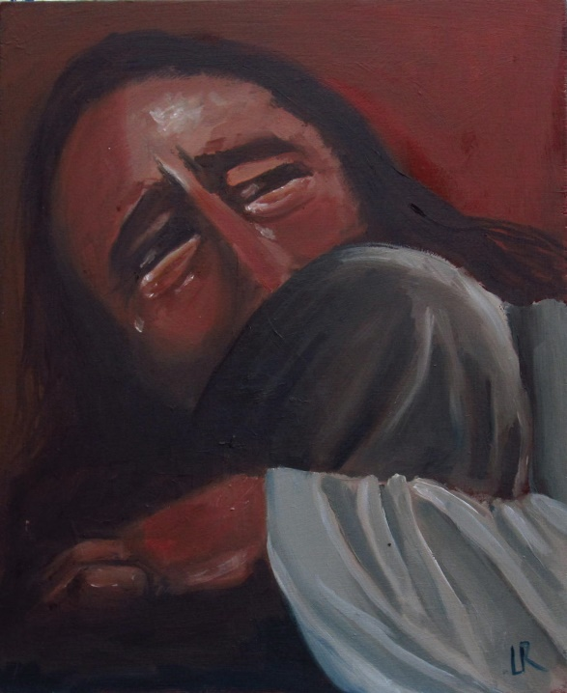

Minister
Rev. Fiona Maxwell

Organist
Mr Alex Ferguson

