The vision of the Church of Scotland is to be a church which seeks to inspire the people of Scotland and beyond with the Good News of Jesus Christ through enthusiastic, worshipping, witnessing, nurturing and serving communities.

Entry of the Bible
(We stand as the Bible is brought into church)
757. Come all ye people,
come and praise your maker,

Grace
Call to Worship
Praise 195 Here to the house of God we come,
home of the people of the Way,
Prayer of Approach & Lord’s Prayer

Reflection: “The Bride of Christ”.

Praise 550 As the deer pants for the water,
so my soul longs after you.

Old Testament. Genesis 21: 8-21 (pg 21)
Olive Gow
Praise 251 I, the Lord of sea and sky,
I have heard my people cry.

Reflection on God’s Word: Sanctuary Sunday.

Praise 198 Let us build a house
where love can dwell,

Prayer of Thanks and Intercession

Praise 360 Jesus Christ is waiting,
waiting in the streets;

Benediction
Amen

Notices
A warm welcome is extended to everyone this morning and especially to any visitors worshipping with us today.

Please take a few minutes to read the screens as there may be information, which was received too late for the printed intimations.

Our minister, the Rev. Fiona Maxwell, can be contacted by telephone on 01563 521762, by mobile on 07507 312123 or by email, FMaxwell@churchofscotland.org.uk

The email address for the Church Administrator is chrchdmnstr@outlook.com. or phone 07394 173977

Session Clerk - Janette Steven
Janette is recovering from replacement knee surgery. During this time Jeff Davies will be supporting the work of the Session Clerk. Jeff can be contacted on, 01563 525243 or email, jeffandsheila@talktalk.net

If you are watching the service via live stream the digital order of service is available on the church website under the services page.

There is now creche and young church facilities in the side chapel, if you have children with you, please use this room as and when you need to.

Tea/coffee will be served after morning worship, please come down to the hall for a warm cuppa and even warmer chat and fellowship.

Young Church are taking a break for the summer, but the side chapel is still available for those who want to use it throughout the summer months.

Fellowship of Kilmarnock Churches – Praise the Lord with Music, Sunday 25 June at 3pm in St Josephs Church. All welcome.

Scalliwags meet Monday at 9.30am – 11am. The group is for all children under 3 and should be accompanied by an adult.

The Guild meet on Tuesday 27 June at 2pm for coffee & chat in the café area of the church, please enter by main front door. All Welcome.

Wednesday café is open every Wednesday morning from 10am – 12 noon. Please tell your friends and neighbours and come and enjoy the company and chat.
Foodbank- Items can still be left at the back of the church in the wicker basket, these items are then taken to the Salvation Army for their foodbank, supplies are required urgently, so please give generously.

www.kayparkparishchurch.org.uk
(Registered Scottish Charity: SC008154)

25th June 2023
4th after Pentecost

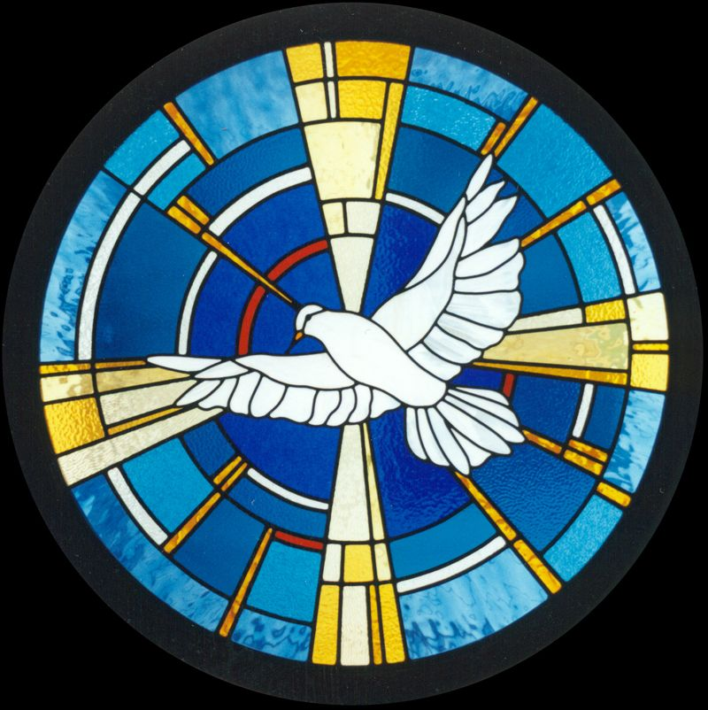

Minister
Rev. Bill Jackson

Organist
Mr Grant Donald

