The vision of the Church of Scotland is to be a church which seeks to inspire the people of Scotland and beyond with the Good News of Jesus Christ through enthusiastic, worshipping, witnessing, nurturing and serving communities.

Entry of the Bible (we stand as the Bible is brought into church)

Grace and Call to Worship

Praise All over the world the Spirit is moving

Prayer of Approach and Lord’s Prayer

Chat to ALL

Praise CH4 194 This is the Day

Bible Reading Acts 2 v 1-4; 12-21 (pg 1093)
(Olive Gow)

Praise CH4 600 Spirit of God, unseen as the wind

REFLECTION on GOD’s WORD

Praise I feel the winds of God today (Tune: Kingsfold)

Prayers of Thanksgiving and for others

Praise CH4 595 O Breath of life
(Tune: Spiritus Vitae)

Benediction

Notices

A warm welcome is extended to everyone this morning and especially to any visitors worshipping with us today.

Please take a few minutes to read the screens as there may be information, which was received too late for the printed intimations.

Our minister, the Rev. Fiona Maxwell, can be contacted by telephone on 01563 521762, or by email, FMaxwell@churchofscotland.org.uk

The email address for the Church Administrator is kppcchurchoffice@gmail.com or phone 07394 173977.

If you are watching the service via live stream the digital order of service is available on the church website under the services page.

Reminder If you have a hearing device, please make sure you have put it to the ‘T‘ position to enable it to link up with the church loop system.

Tea/coffee will be served after morning worship, please come down to the hall for a warm cuppa and even warmer chat and fellowship.

The Guild meet on Tuesday 26 May at 2pm in the hall for their AGM.

Wednesday Walkers meet at the Kay Park at 10am at the top car park near the Burns Centre, enjoy a walk round the park and a good chat. All welcome.

Wednesday Café 10am – 12 noon all welcome for a cuppa and chat.

Spring Concert at New Laigh Kirk - 28 May @ 7.30pm. Relax and enjoy Crossroads Community Choir's medley of music. Admission £6.

The Keswick Ayrshire Convention will be held at the Park Hotel on the evenings of 29th , 30th 31st May 7.30 – 9.30. Entry is free and there will be an opportunity to make donations. The theme is “Finding God in Hard Places”. The Keynote speaker, Ian Coffey, is a Baptist Minister who has led churches in British and international contexts. He speaks at conferences in many parts of the world and has written 14 books. His passion is to teach the Bible in language people can understand. At Moorlands College Ian specializes in leadership training and development.

Holy Communion Sunday 7 June 11am.

Praise Night at Kay Park Parish Church - 7 June @ 7pm. You are invited to join KPPC's Choir and Praise Band for a relaxed hour of worship and praise. Details are on the attached poster. There will be a retiring offering for Ayrshire Cancer Support and Parkinson's UK.

Community Litterpick - The second Litterpick of the year will be held on Saturday 20th June based ar the New Laigh Parish Church in Kilmarnock at 9.30am. Anyone interested in supporting this important community project should contact Jeff Davies on 07917 701714 or email at jeffandsheila@talktalk.net All equipment will be supplied and bacon rolls with tea or coffee supplied free of charge.

Foodbank- Items can still be left at the back of the church in the wicker basket, these items are then taken to the Salvation Army for their foodbank, supplies are required urgently, so please give generously.

Stamps If you are one of the few people who still gets letters with stamps we are looking for your stamps. There will be a box in the café area for you to put them, these will then be trimmed and sent away to Embrace the Middle East or Mercy Ships.

New to Kay Park?
If you are new to Kay Park, please feel free to approach the Minister, Rev Fiona on (01563) 521762 or the Session Clerk, Jean Johnston, 07944 891078, for further information about the Church and Membership. If you would like information about giving to the church financially, please contact the Treasurer, Gordon Slater 07768 780051

Back by popular demand for 2026
Postcards from around the Globe
We would love to see where you’ve travelled to this holiday season. If you’re away for a holiday or just a day trip then either send us a postcard or bring one back and put it in the post box at the back of the church.
Kay Park Parish Church, London Road, Kilmarnock, KA3 7AA


www.kayparkparishchurch.org.uk
(Registered Scottish Charity: SC008154

Pentecost
Sunday 24 May 2026

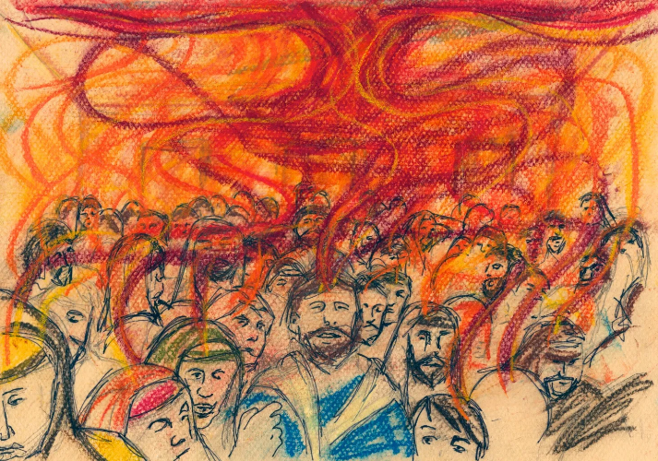

Minister
Rev Fiona Maxwell

Lead Musician
Charles Donnelly

