The vision of the Church of Scotland is to be a church which seeks to inspire the people of Scotland and beyond with the Good News of Jesus Christ through enthusiastic, worshipping, witnessing, nurturing and serving communities.

(3.50 Carol Singing with the choir & young church)
Welcome

Reading ‘Our God is Here

Carol 294 On Christmas Night all Christians Sing

Prayer
Christmas Marching Song

Carol All the Angels Sing

Christmas School Assembly Bangers

Reading “Come Light of Life”

Cloth for the Cradle
We listen to ‘Celtic Christmas Blessing’

A Christmas Crib Prayer
(David Adam)

Praise 306 O Come all ye faithful (Omit v 2)

Benediction

GOD BE WITH YOU THIS CHRISTMAS TIME & ALWAYS!

Notices

A warm welcome is extended to everyone this afternoon and especially to any visitors worshipping with us today.

Our minister, the Rev. Fiona Maxwell, can be contacted by telephone on 01563 521762, or by email, FMaxwell@churchofscotland.org.uk

The email address for the Church Administrator is kppcchurchoffice@gmail.com or phone 07394 173977.

If you are watching the service via live stream the digital order of service is available on the church website under the services page.

Reminder If you have a hearing device, please make sure you have put it to the ‘T‘ position to enable it to link up with the church loop system.

Foodbank- Items can still be left at the back of the church in the wicker basket, these items are then taken to the Salvation Army for their foodbank, supplies are required urgently, so please give generously.

New to Kay Park?
If you are new to Kay Park, please feel free to approach the Minister, Rev Fiona on (01563) 521762 or the Session Clerk, Jean Johnston, 07944 891078, for further information about the Church and Membership. If you would like information about giving to the church financially, please contact the Treasurer, Gordon Slater 07768 780051

Sunday 28 December at 11am Last Sunday of 2025 ‘Ring out the Old, Bring in the New’


www.kayparkparishchurch.org.uk
(Registered Scottish Charity: SC008154)

Wednesday 24 December 2025
CHRISTMAS EVE
4pm

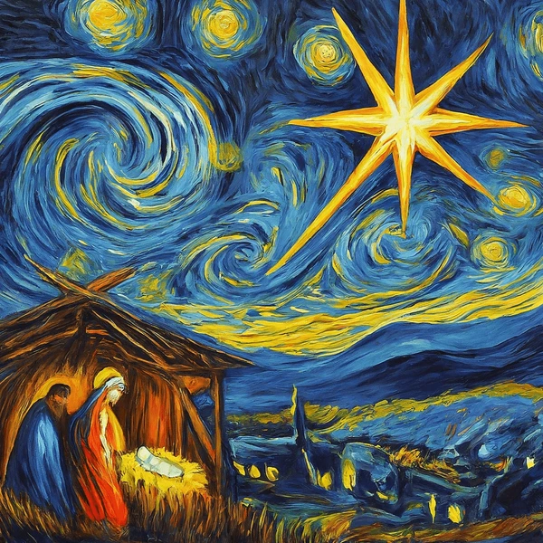

Minister
Rev. Fiona Maxwell

Organist
Mr Alex Ferguson

