The vision of the Church of Scotland is to be a church which seeks to inspire the people of Scotland and beyond with the Good News of Jesus Christ through enthusiastic, worshipping, witnessing, nurturing and serving communities.

10.45 Carol Singing with the choir

Entry of the Bible
(we stand as the Bible is brought into church)

Welcome - Call to Worship

Candle Nativity

Carol 306 O Come, all Ye Faithful (omit verse 2)

Lighting of Advent Candle

Prayer

Young Church Little Donkey
All the Angels Sing

Music Out of the Box Puppets

Reading ‘God with us’ – (More Christmas Unwrapped)

Carol MP42 At this time of Giving

CRISP-Tingle!

Carol 309 Still the Night

Cloth for the Cradle - Reading & Response

Prayers of Thanksgiving and for others

Praise 301 Hark the Herald Angels Sing

Benediction
(followed by MP 556 ‘Peace to you’)

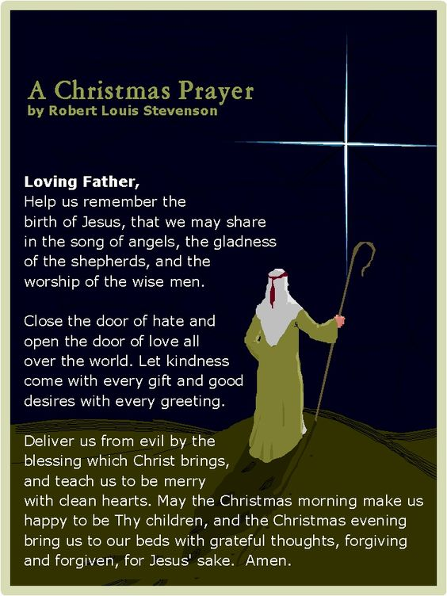

Notices

A warm welcome is extended to everyone this morning and especially to any visitors worshipping with us today.

Our minister, the Rev. Fiona Maxwell, can be contacted by telephone on 01563 521762, by mobile on 07507 312123 or by email, FMaxwell@churchofscotland.org.uk

The email address for the Church Administrator is kppcchurchoffice@gmail.com or phone 07394 173977. Please note the new email address for the church administrator.

Tea/coffee will be served after morning worship, please come down to the hall for a warm cuppa and even warmer chat and fellowship.

Wednesday cafe will be closed on the 27th December and 3rd January. We will reopen on Wednesday 10th January.

From Fiona, our Minister...

I would like to extend my sincere thanks for all the lovely Christmas Cards given to me this year and for all your ongoing love, support and prayers.
As the year draws to a close
- Thank you to our staff Vanessa, Paul and Robbie for their hard work over the year.
- Thank you to Alex Ferguson, Grant Donald and the Choir for their contribution to our worship and for leading us weekly in praise.
- Thank you to the Media Team for all your work on a Sunday and in preparation for a Sunday.
And finally, Thank you, to every one of you in the church family of Kay Park for all you 'are' and all you 'do' as a community of faith in service of God, one another and the wider community.

I wish you all God's Blessing this Christmas time and his abiding presence in the year to come.

'Not to us, O Lord, not to us but to your name be the glory because of your love and faithfulness' (Psalm 115v1)

with love, Rev Fiona.

www.kayparkparishchurch.org.uk
(Registered Scottish Charity: SC008154)

Sunday 24 December 2023
CHRISTMAS EVE

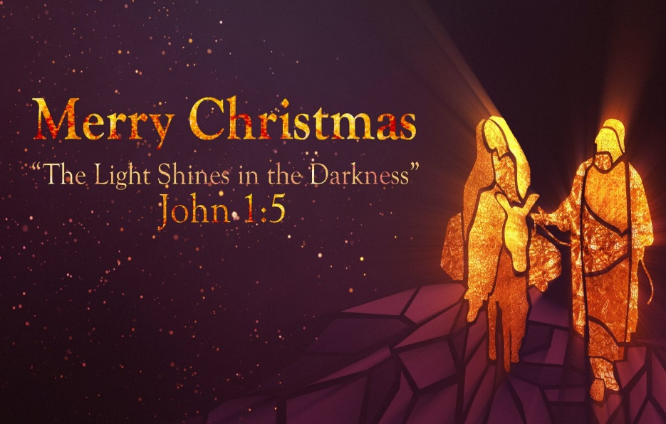

Minister
Rev. Fiona Maxwell

Organist
Mr Alex Ferguson

