The vision of the Church of Scotland is to be a church which seeks to inspire the people of Scotland and beyond with the Good News of Jesus Christ through enthusiastic, worshipping, witnessing, nurturing and serving communities.

Entry of the Bible (we stand as the Bible is brought into church)

Grace and Call to Worship

Praise 449 Rejoice! The Lord is King

Prayer of Approach and Lord’s Prayer

SACRAMENT OF BAPTISM (followed by ‘The Lord Bless you’ CH4 796)

Praise 633 Child of Blessing (Tune: Servant Song)

Bible Reading Philippians ch 2 v 4 – 11 (pg 1179)
(Aileen Samsun)

Praise 356 Meekness and Majesty

REFLECTION ON GOD’S WORD

Anthem ‘The Prayer’

Prayers of Thanksgiving and for others

Praise 456 Christ is the world’s true light (Tune: Nun Danket)

Benediction

Notices

A warm welcome is extended to everyone this morning and especially to any visitors worshipping with us today.

We welcome the family and friends of Andrew and Lauren Slater who bring their children Rory and Violet for baptism today.

Please take a few minutes to read the screens as there may be information, which was received too late for the printed intimations.

Our minister, the Rev. Fiona Maxwell, can be contacted by telephone on 01563 521762, or by email, FMaxwell@churchofscotland.org.uk

The email address for the Church Administrator is kppcchurchoffice@gmail.com or phone 07394 173977.

If you are watching the service via live stream the digital order of service is available on the church website under the services page.

Reminder If you have a hearing device, please make sure you have put it to the ‘T‘ position to enable it to link up with the church loop system.

Tea/coffee will be served after morning worship, please come down to the hall for a warm cuppa and even warmer chat and fellowship.

Fellowship of Kilmarnock Churches – Stepping Out Churches at work in our community. Today Sunday 23 November at 3pm in Salvation Army.

Praise Evening, Alex, Grant and Stacey invite you to join them tonight Sunday 23 November at 6.30pm in the church for an informal hour of Praise and Worship. There will be a plate at the door for donations to Crossrreach.

Wednesday Walkers meet at the Kay Park at 10am at the top car park near the Burns Centre, enjoy a walk round the park and a good chat. All welcome.

Wednesday Café 10am – 12 noon all welcome for a cuppa and chat.

Friendship Club meet on Thursday 13 November at 2pm for a Christmas stall & Quiz.

Striders meet on Friday 28 November at 10am on Munro Avenue, Kilmarnock, roughly opposite Margaret Parker Avenue with parking available in a parking lane on Munro Avenue.

Hurlford Church Guild Christmas Fayre Saturday 29 November 11am – 2pm in Hurlford Community Centre.

St Kentigerns Ceilidh Saturday 29 November 6.30pm – 9pm, please give your names to Jean Johnston if you are interested in going to this event.

Gift Sunday, Sunday 30 November 11am if you are able please bring an unwrapped gift to this service for a child/young person aga 0 – 18 and these will be distributed by the Salvation Army to those who are in need in Kilmarnock.

Christmas Trail Sunday 30 November 1.30pm – 4pm, visit all the town churches and enjoy an activity at each church. Then head into the town for the switching on of the Christmas lights.

Blue Christmas Sunday 7 December 3pm.

Foodbank- Items can still be left at the back of the church in the wicker basket, these items are then taken to the Salvation Army for their foodbank, supplies are required urgently, so please give generously.

New to Kay Park?
If you are new to Kay Park, please feel free to approach the Minister, Rev Fiona on (01563) 521762 or the Session Clerk, Jean Johnston, 07944 891078, for further information about the Church and Membership. If you would like information about giving to the church financially, please contact the Treasurer, Gordon Slater 07768 780051

Stamps If you are one of the few people who still gets letters with stamps we are looking for your stamps. There will be a box in the café area for you to put them, these will then be trimmed and sent away to Embrace the Middle East or Mercy Ships.

Christmas Lunch Sunday 14 December 12.15. Tickets for the Christmas Lunch will be on sale next Sunday 23 November at the church office at a suggested donation of £7.

Fellowship of Kilmarnock Churches latest newsletter is available at the back of the church, please take one if you wish.

Fiona Kendall – Mission Partner Newsletter is available at the back of the church, please feel free to take one.

www.kayparkparishchurch.org.uk
(Registered Scottish Charity: SC008154

CHRIST THE KING SUNDAY
Sunday 24 November 2025

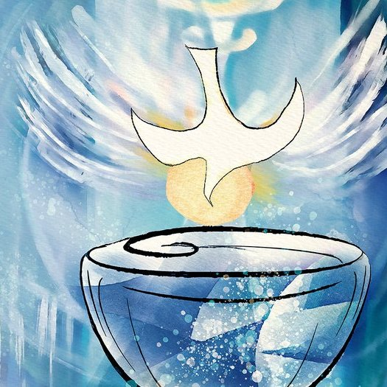

Minister
Rev Fiona Maxwell

Organist
Alex Ferguson

