The vision of the Church of Scotland is to be a church which seeks to inspire the people of Scotland and beyond with the Good News of Jesus Christ through enthusiastic, worshipping, witnessing, nurturing and serving communities.

Entry of the Bible
(We stand as the Bible is brought into church)

Grace
Call to Worship
Praise 132 Immortal, invisible, God only wise,

Prayer of Approach & Lord’s Prayer

Reflection: Lost and Found.

Praise 249 We have heard a joyful sound,
‘Jesus saves!’

Gospel. St. Matthew 13: 24-30, 36-43 (pg 979)
(Audrey Gray)

Praise 343* The reign of God, like farmer’s field,
*(Tune: Wiltshire. See CH4 14.3.)

Reflection on God’s Word: Wheat and Weeds Together.

Praise 623 Here in this place new life is streaming,

Prayer of Thanks and Intercession

Praise 476 Mine eyes have seen the glory
of the coming of the Lord:

Benediction
Amen

Notices
A warm welcome is extended to everyone this morning and especially to any visitors worshipping with us today.

Please take a few minutes to read the screens as there may be information, which was received too late for the printed intimations.

Our minister, the Rev. Fiona Maxwell, can be contacted by telephone on 01563 521762, by mobile on 07507 312123 or by email, FMaxwell@churchofscotland.org.uk

The email address for the Church Administrator is chrchdmnstr@outlook.com. or phone 07394 173977

If you are watching the service via live stream the digital order of service is available on the church website under the services page.

There is now creche and young church facilities in the side chapel, if you have children with you, please use this room as and when you need to.

Tea/coffee will be served after morning worship, please come down to the hall for a warm cuppa and even warmer chat and fellowship.

Young Church are taking a break for the summer, but the side chapel is still available for those who want to use it throughout the summer months.

Wednesday Walkers meet at the Kay Park at 10am at the 4top car park near the Burns Centre, enjoy a walk round the park and a good chat and then have coffee/tea in the church café. All welcome.

Wednesday café is open every Wednesday morning from 10am – 12 noon. Please tell your friends and neighbours and come and enjoy the company and chat.

The Guild meet on Tuesday 25 July at 2pm for coffee & chat in the church café, please enter by main front door. All welcome

Aoife’s Sensory Bus will be visiting the Howard Centre on Wednesdays 19th and 26th July from 10.30am to 2pm. The bus lets children enjoy an interactive sensory environment. To book or for more information please contact Elaine Wardrop: ewardrop@churchofscotland.org.uk
Holiday Clubs
“Diary of a Disciple” Summer Holiday Club for Primary School Children: Mon 7th – Fri 11th August 10.30 till12 noon in St Kentigern's Church Hall. If you are PVG-cleared and would be interested in helping at the holiday club then please contact Anne McCabe 07780 755878 for more information.

Safari Summer Club 14 – 16 August at New Laigh Kirk Church Halls from 6pm to 8pm for all Primary 1 – 7 children. All Welcome

The Church Newsbite is available at the back of the church for anyone who wants one or if you want to pass it on to a friend.

The Fellowship of Kilmarnock Churches July 2023 Newsletter is available at the back of the church, please take a copy and read about all the great things that are happening in the town.

The welcoming team are an important part of Sunday morning worship. We urgently need new volunteers to join the team so if you are willing to be on once every 8 weeks, please speak to Janette Steven. The duties include welcoming people as they arrive and then being at the door at the end of worship to see people on their way.

Foodbank- Items can still be left at the back of the church in the wicker basket, these items are then taken to the Salvation Army for their foodbank, supplies are required urgently, so please give generously.

www.kayparkparishchurch.org.uk
(Registered Scottish Charity: SC008154)

23rd July 2023
8th after Pentecost

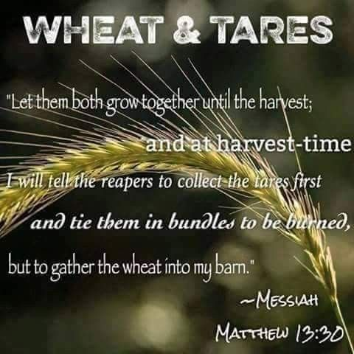

Minister
Rev. Bill Jackson

Organist
Mr . Charles Donnelly

