The vision of the Church of Scotland is to be a church which seeks to inspire the people of Scotland and beyond with the Good News of Jesus Christ through enthusiastic, worshipping, witnessing, nurturing and serving communities.

Entry of the Bible
(we stand as the Bible is brought into church)

Welcome and Notices

Introit

Grace & Call to Worship

Praise 367 Hosanna, Loud Hosanna

Prayer of Approach and the Lord’s Prayer

Bible Reading Matthew chapter 21 v 1 – 11 (Pg 988)
(Elizabeth Templeton)

Anthem

Reflection on God’s Word – Litany of the Palms

Praise 399 My song is love unknown (v’s 1-3 &7 only)

Young Church

Praise MP242 Hosanna, Hosanna, Hosanna in the highest

Prayers of Thanksgiving & for Others

Praise 279 Make Way, Make Way

Benediction

Notices
A warm welcome is extended to everyone this morning and especially to any visitors worshipping with us today.

Please take a few minutes to read the screens as there may be information, which was received too late for the printed intimations.

Our minister, the Rev. Fiona Maxwell, can be contacted by telephone on 01563 521762, by mobile on 07507 312123 or by email, FMaxwell@churchofscotland.org.uk

The email address for the Church Administrator is chrchdmnstr@outlook.com. or phone 07394 173977

If you are watching the service via live stream the digital order of service is available on the church website under the services page.

There is now creche and young church facilities in the side chapel, if you have children with you, please use this room as and when you need to.

Tea/coffee will be served after morning worship, please come down to the hall for a warm cuppa and even warmer chat and fellowship.

Scalliwags meet Monday at 9.30am – 11am. The group is for all children under 3 and should be accompanied by an adult.

Brownies & Guides 17th Kilmarnock Brownies and 6th Kilmarnock Guides will meet in the church halls on Monday at 6pm and 7.30pm.

Wednesday café is open every Wednesday morning from 10am – 12 noon. Please tell your friends and neighbours and come and enjoy the company and chat.

Strollers' will meet on Thursday 6th April and will walk around Rozelle Estate in Alloway. Assemble for 10am in the first car park on your right on entering the estate.

We are also trying a new venture on Wednesday 12th April with a stroll around Kay Park. This will be a short stroll and is intended to accommodate all interested in taking part. Anyone interested should assemble for 10am at the car park adjacent to the Burns Centre, Kay Park. After the walk, we will retire to the Church Cafe for tea / coffee.

The final total of the Guild Coffee Morning was a wonderful £ 904.04 - thank you to everyone who supported our guild and the C. of S. Projects !!

Foodbank – donations of Easter Eggs will be much appreciated this week.

Please remember to bring a flower to church on Easter Sunday to decorate the Easter Cross. Thank you.

Foodbank- Items can still be left at the back of the church in the wicker basket, these items are then taken to the Salvation Army for their foodbank, supplies are required urgently, so please give generously.
Some items that are often forgotten are: Tin Openers, Toiletries, Toilet Rolls, Detergent/washing up liquid, Nappies and other baby supplies, Free from all items e.g Gluten Free

Tickets are now available for the Coronation event on Saturday 6 May. Jess Barry & Vanessa Twomey will have them on sale over the next 3 weeks.

Employment Opportunity Kay Park Parish Church, London Road Kilmarnock, KA3 7AA
Part-time Evening Caretaker/Cleaner Salary: £4534.40 per annum (£10.90 per hour) Contracted for 8 hours per week but with the possibility of extra when required. 45 hours holiday payment per annum plus pro rata public holiday entitlement. Currently hours are worked over Monday, Wednesday & Thursday evenings but may change depending on hall let requirements. Duties will include: opening & closing building for lets, ensuring Health & safety during periods of let, a rota of light cleaning duties and security of the building. Candidates should be flexible and able to problem solve, comfortable talking to hiring groups, willing to undertake cleaning duties, complete relevant checks and be respectful of the Church of Scotland’s vision which can be found on the website http://kayparkparishchurch.org.uk/ This post requires the successful candidate to undertake a Disclosure Scotland PVG
Apply by sending an e-mail of interest to: jean_herb@outlook.com by 13th April with interview planned for Thursday 17th April. Please provide the following information:
Name, Address, Telephone number, e-mail, why you would be suited to this post & details of 2 referees
www.kayparkparishchurch.org.uk
(Registered Scottish Charity: SC008154)

Palm/Passion Sunday
2 April 2023

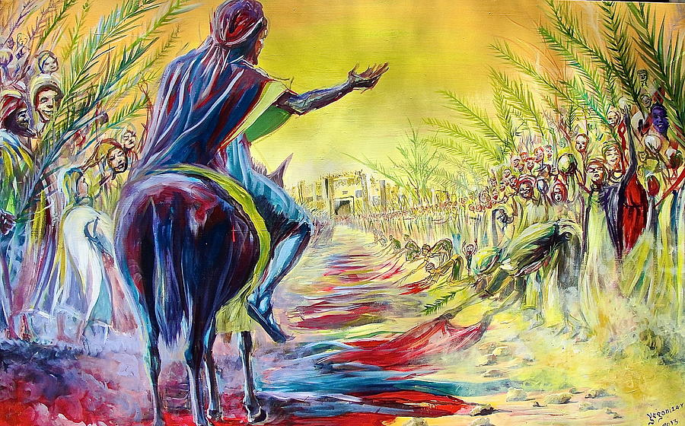
(Palm Sunday by Evans Yegon).

Minister
Rev. Fiona Maxwell

Organist
Mr Alex Ferguson

