The vision of the Church of Scotland is to be a church which seeks to inspire the people of Scotland and beyond with the Good News of Jesus Christ through enthusiastic, worshipping, witnessing, nurturing and serving communities.

Entry of the Bible
(we stand as the Bible is brought into church)

Welcome - Grace and Call to Worship

Lighting of Advent Candles

Carol 310 See him lying on a bed of straw

Prayer of Approach and Lord’s Prayer

NATIVITY – THE A, B, C’S OF CHRISTMAS
during which we will sing the following Carols
A – F 304 O little Town of Bethlehem (v1&2)
G - I 304 O little Town of Bethlehem (v3&4) after letter ‘G
Bible Reading Luke 2 v 8 – 16 (pg 1027)
(Vanessa Twomey)
J – M 312 Away in a Manger
N – P Choir (during which our Nativity tableau is created)
Prayers
Q – W (Young Church) It was on a Starry night
X – Z (Young Church) All the Angels Sing (reprise)

Carol 321 Come and join the celebration

Benediction

Notices

A warm welcome is extended to everyone this morning and especially to any visitors worshipping with us today.

Please take a few minutes to read the screens as there may be information, which was received too late for the printed intimations.

Our minister, the Rev. Fiona Maxwell, can be contacted by telephone on 01563 521762, by mobile on 07507 312123 or by email, FMaxwell@churchofscotland.org.uk

The email address for the Church Administrator is kppcchurchoffice@gmail.com or phone 07394 173977. Please note the new email address for the church administrator.

If you are watching the service via live stream the digital order of service is available on the church website under the services page.

There is now creche and young church facilities in the side chapel, if you have children with you, please use this room as and when you need to.

Tea/coffee will be served after morning worship, please come down to the hall for a warm cuppa and even warmer chat and fellowship.

Wednesday Walkers meet at the Kay Park at 10am at the top car park near the Burns Centre, enjoy a walk round the park and a good chat and then have coffee/tea in the church café. All welcome.

Wednesday café is open every Wednesday morning from 10am – 12 noon. Please tell your friends and neighbours and come and enjoy the company and chat.

Next Sunday 24 December Christmas Eve, all age service at 11am.

The funeral of Ms Karen Presly will take place on TUESDAY, 9 January at 11.15am in Kay Park Parish Church and thereafter at 12.30 in Holmsford Bridge Crematorium. Please remember Karen's family and friends in your prayers.

Foodbank- Items can still be left at the back of the church in the wicker basket, these items are then taken to the Salvation Army for their foodbank, supplies are required urgently, so please give generously.

Many hands!
There are times in the church year, December being one of them, when the Sanctuary is used for large concerts/events. It is great to host these gatherings but is a lot of work in terms of setting and resetting the chairs etc. If you would be willing to give some time (likely, 30 mins or so after an event) to help tidy and set things up again can you please give your name to Vanessa. email, kppcchurchoffice@gmail.com Thank you!

Blue Christmas
This year we have a table next to the side chapel laid out with a tree and blue labels, you can write the name of a loved one, whom you would like to be remembered, on a label and hang it on the tree.

New to Kay Park?
If you are new to Kay Park, please feel free to approach the Minister, Rev Fiona on (01536) 521762 or the Session Clerk, Janette Steven, (01563) 401209, for further information about the Church and Membership. If you would like information about giving to the church financially, please contact the Treasurer, Alex Steven on 01563 401209

www.kayparkparishchurch.org.uk
(Registered Scottish Charity: SC008154)

Sunday 17 December 2023

THIRD SUNDAY IN ADVENT

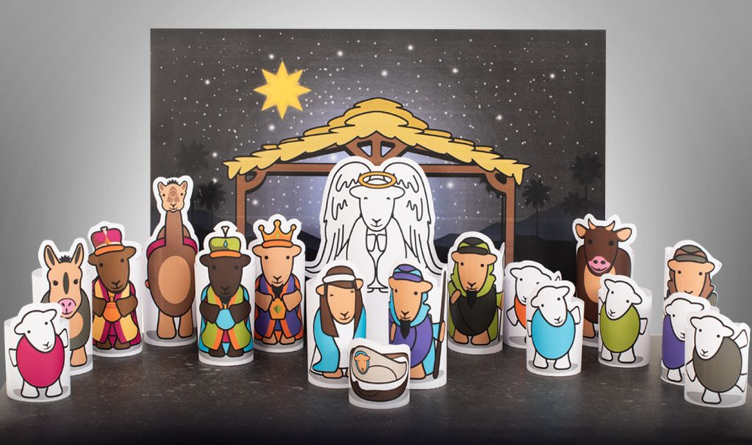

Minister
Rev. Fiona Maxwell

Organist
Mr Alex Ferguson

