Entry of the Bible (we stand as the Bible is brought into church)

Grace and Call to Worship

Praise 175 Praise, I will praise you, Lord

Prayer of Approach and Lord’s Prayer
BLESSING as SCHOOL RETURNS

Praise Video May the Lord Bless you

Bible Readings
Old Testament - Psalm 78 v 1 – 7 (pg 590)
New Testament – Acts of the Apostles 17 v 22-28 (pg 1113)
(Tracey Neilson)

Praise 588 Praise the Spirit in Creation (v1&2)
(Tune: Regent Square)

REFLECTION ON GOD’S WORD

Praise 588 Praise the Spirit in Creation (v3&4)

Prayers of Thanksgiving and for others

Praise 159 Lord, for the years

Benediction

Notices

A warm welcome is extended to everyone this morning and especially to any visitors worshipping with us today.

Please take a few minutes to read the screens as there may be information, which was received too late for the printed intimations.

Our minister, the Rev. Fiona Maxwell, can be contacted by telephone on 01563 521762, or by email, FMaxwell@churchofscotland.org.uk

The email address for the Church Administrator is kppcchurchoffice@gmail.com or phone 07394 173977.

If you are watching the service via live stream the digital order of service is available on the church website under the services page.

Reminder If you have a hearing device, please make sure you have put it to the ‘T‘ position to enable it to link up with the church loop system.

Tea/coffee will be served after morning worship, please come down to the hall for a warm cuppa and even warmer chat and fellowship.

Wednesday Walkers meet at the Kay Park at 10am at the top car park near the Burns Centre, enjoy a walk round the park and a good chat. All welcome.

Wednesday café 10am – 12 noon. The café is now serving toast and cup-a-soup. Please tell your friends and neighbours and come and enjoy the company and chat.

Litter Pick The Church plans to have the second Litter Pick of 2025 on Saturday 30th August meeting in the Church car park at 10.00am. Equipment and litter bags will be provided along with a full Health and Safety induction. A snack lunch will be provided afterwards by the Church in the Hall. This is always well attended and is part of our Church policy of supporting the local Community and environment. This will only involve a couple of hours of your time. Anyone interested in joining us should give their names to Jeff Davies or text to 07917 360887.

Pilgrimage/Church Outing
It is being proposed to revive our church pilgrimage. This entails a weekend away bus trip next Summer.
A rough outline of the trip is as follows: Going to Northumbria, visiting Alnwick Castle/gardens on Sat, spending Sat night at an hotel near Alnwick, worshipping on Lindisfarne on Sunday morning and visiting Bamburgh Castle in the afternoon. With stops along the way for food and comfort breaks. Costings still to be worked out but to be viable a full coach is required. Therefore, expressions of interest are needed to explore this venture further. Names to be given to Janette Steven phone 07788 298355

Foodbank- Items can still be left at the back of the church in the wicker basket, these items are then taken to the Salvation Army for their foodbank, supplies are required urgently, so please give generously.

New to Kay Park?
If you are new to Kay Park, please feel free to approach the Minister, Rev Fiona on (01563) 521762 or the Session Clerk, Jean Johnston, 07944 891078, for further information about the Church and Membership. If you would like information about giving to the church financially, please contact the Treasurer, Gordon Slater 07768 780051

Poppy Appeal
For Remembrance Sunday this year we are planning on having a poppy display, so we need your help. If you can knit and are willing, we are looking for as many red poppies as possible. We are also looking for a few White, Blue and Purple poppies. The pattern can be found in the café area, please take one and get those knitting needles out. In the coming weeks there will be a box in the café area to put your completed poppies. We need these by Sunday 19 October. Thank you.

Stamps If you are one of the few people who still gets letters with stamps we are looking for your stamps. There will be a box in the café area for you to put them, these will then be trimmed and sent away to Embrace the Middle East or Mercy Ships.


www.kayparkparishchurch.org.uk
(Registered Scottish Charity: SC008154)

Sunday 17 August 2025

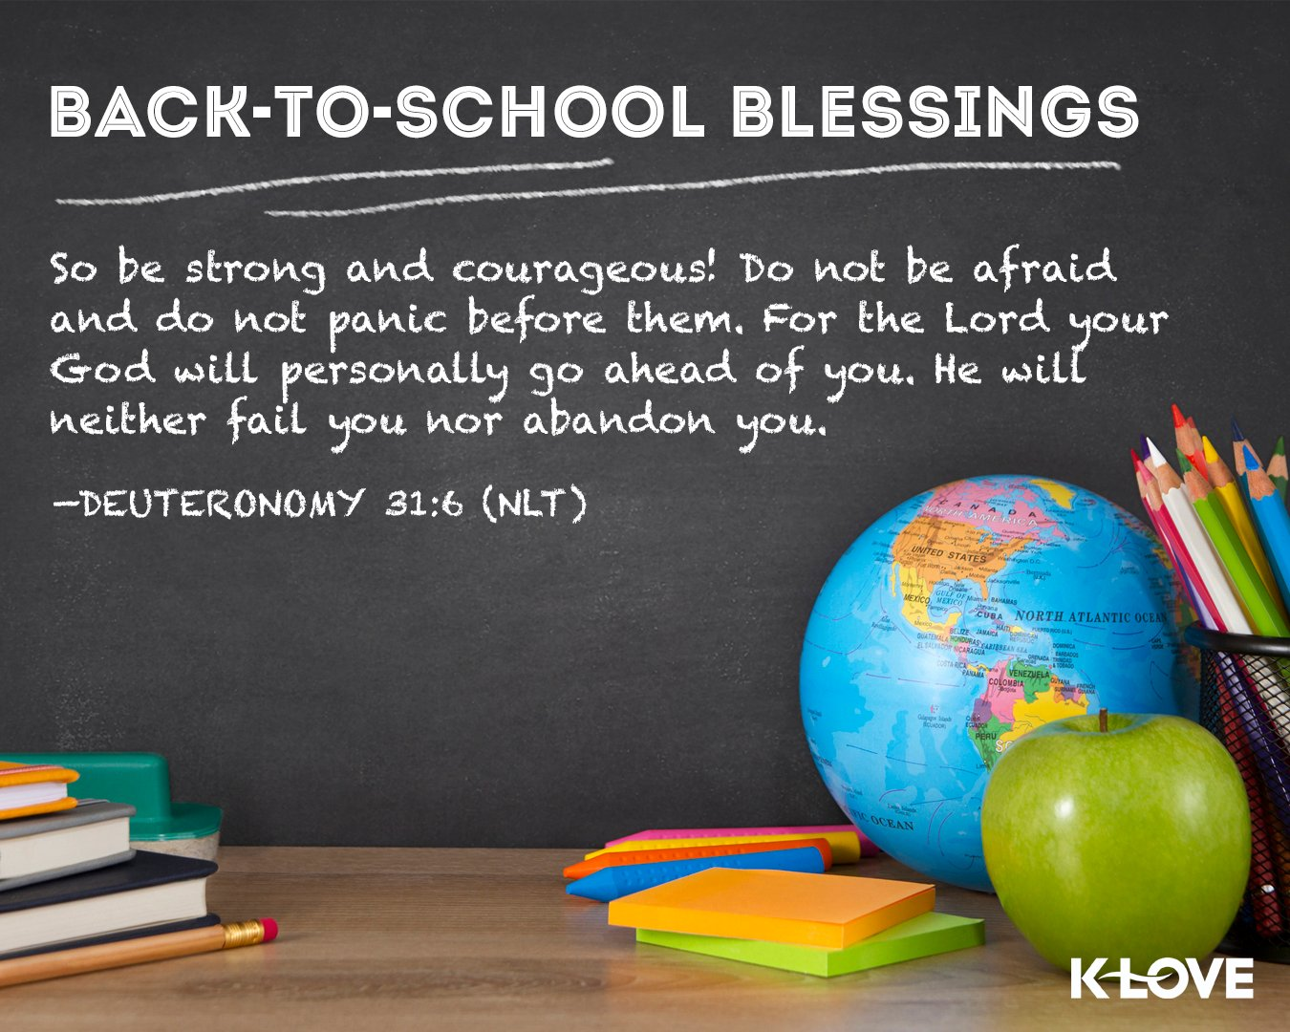

Minister
Rev Fiona Maxwell

Organist
Mr Charles Donnelly

