The vision of the Church of Scotland is to be a church which seeks to inspire the people of Scotland and beyond with the Good News of Jesus Christ through enthusiastic, worshipping, witnessing, nurturing and serving communities.

Entry of the Bible (we stand as the Bible is brought into church)

Grace and Call to Worship

Praise 69 Just as a Father shows his love (Tune: Kilmarnock)

Prayer of Approach and Lord’s Prayer

Talk 1 “Tabeetha School – An Introduction”

Praise 250 Sent by the Lord am I

Bible Reading Acts chapter 9 v 36-42 (pg 1103)
(Jeff Davies)

Praise 721 We lay our broken world

Talk 2 “Tabeetha School – A Beacon of Hope”

Anthem “When hands reach out” (Keri K. Wehlander)

Prayers of Thanksgiving and for others

Praise GWA 224 Sing a new world into being (Tune: Hyfrydol)

Benediction

Notices

A warm welcome is extended to everyone this morning and especially to any visitors worshipping with us today.

Please take a few minutes to read the screens as there may be information, which was received too late for the printed intimations.

Our minister, the Rev. Fiona Maxwell, can be contacted by telephone on 01563 521762, or by email, FMaxwell@churchofscotland.org.uk

The email address for the Church Administrator is kppcchurchoffice@gmail.com or phone 07394 173977.

If you are watching the service via live stream the digital order of service is available on the church website under the services page.

Reminder If you have a hearing device, please make sure you have put it to the ‘T‘ position to enable it to link up with the church loop system.

Tea/coffee will be served after morning worship, please come down to the hall for a warm cuppa and even warmer chat and fellowship.

Wednesday Walkers meet at the Kay Park at 10am at the top car park near the Burns Centre, enjoy a walk round the park and a good chat. All welcome.

Wednesday Café 10am – 12 noon all welcome for a cuppa and chat.

Faith Stories Wednesday 11 March at 7pm in the café area of the church.

Friendship Club meet on Thursday 19 March at 2pm for a musical afternoon, all are welcome.

Craft Fayre at KPPC Saturday 21 March 10am – 4pm Stalls, raffle, bottle stall, refreshments.

Retiring Offering There will be a retiring offering on Sunday 22 March for the work of Tabeetha School, Jaffa.

Kirk Session will meet on Wednesday 25 March at 7pm in the hall.

Easter Sunday 5 April the Flower Committee plan to make their Easter Cross, please plan to bring a flower with you for the flower cross. Thank you.

The Guild are selling tickets for their Scottish music & dance fundraiser on 10 April at 7.30pm. Tickets are £7 and if you would like one then please speak to a member of the Guild.

Foodbank- Items can still be left at the back of the church in the wicker basket, these items are then taken to the Salvation Army for their foodbank, supplies are required urgently, so please give generously.

New to Kay Park?
If you are new to Kay Park, please feel free to approach the Minister, Rev Fiona on (01563) 521762 or the Session Clerk, Jean Johnston, 07944 891078, for further information about the Church and Membership. If you would like information about giving to the church financially, please contact the Treasurer, Gordon Slater 07768 780051

Stamps If you are one of the few people who still gets letters with stamps we are looking for your stamps. There will be a box in the café area for you to put them, these will then be trimmed and sent away to Embrace the Middle East or Mercy Ships.

Questions for Jesus
Thank you to all those who have posted a question bubble in the box. We already have over 30. The box will be there for another two Sundays.

The latest edition of Newsbite (the Church magazine) is now available at the back of the church, please take one if you don’t get one delivered or if you are visiting the church.


www.kayparkparishchurch.org.uk
(Registered Scottish Charity: SC008154

Lent 3
Sunday 15 March 2026

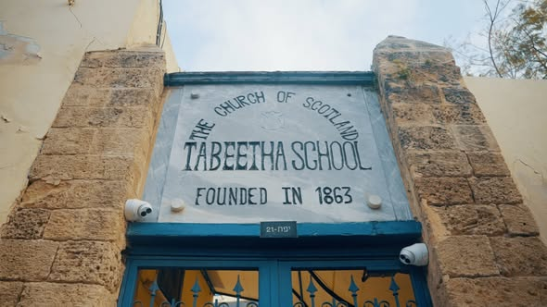

Minister
Rev Fiona Maxwell

Guest Speaker
Ms Kate Freedman

Lead Musician
Mr Alex Ferguson

