/
The vision of the Church of Scotland is to be a church which seeks to inspire the people of Scotland and beyond with the Good News of Jesus Christ through enthusiastic, worshipping, witnessing, nurturing and serving communities.

Entry of the Bible (we stand as the Bible is brought into church)

Grace and Call to Worship

Praise CH4 356 Meekness and Majesty

Prayer of Approach and Lord’s Prayer

CHAT TO ALL

Praise CH4 481 Jesus is the name we honour

Bible Reading Matthew 17 v 1 - 9 (pg 986)
(Vanessa Twomey)

Praise CH4 189 Be still for the presence of the Lord

REFLECTION ON GOD’S WORD

ANTHEM

Prayers of Thanksgiving and for others

Praise 519 Love Divine, all loves excelling

Benediction

Notices

A warm welcome is extended to everyone this morning and especially to any visitors worshipping with us today.

Please take a few minutes to read the screens as there may be information, which was received too late for the printed intimations.

Our minister, the Rev. Fiona Maxwell, can be contacted by telephone on 01563 521762, or by email, FMaxwell@churchofscotland.org.uk

The email address for the Church Administrator is kppcchurchoffice@gmail.com or phone 07394 173977.

If you are watching the service via live stream the digital order of service is available on the church website under the services page.

Reminder If you have a hearing device, please make sure you have put it to the ‘T‘ position to enable it to link up with the church loop system.

Tea/coffee will be served after morning worship, please come down to the hall for a warm cuppa and even warmer chat and fellowship.

Wednesday Walkers meet at the Kay Park at 10am at the top car park near the Burns Centre, enjoy a walk round the park and a good chat. All welcome.

Wednesday Café 10am – 12 noon all welcome for a cuppa and chat.

Kirk Session meet at 7pm in the hall.

Friendship Club meet on Thursday 19 February at 2pm for an afternoon of favourite hymns. All are welcome,

Striders' walk will be on Monday 23rd February. This will be the walk intended for January which was "rained off". Assemble, for 10am, in the Titchfield Road car park, Troon. KA10 6AN. This is on the site of the former outdoor swimming pool.

You won't pay New York prices if you take the opportunity to listen to the Quartet in Kilmarnock! Lorna Reid and her band will perform for one night only at 7 p.m. on Saturday, 14 March, in New Laigh Kirk Halls, 35 John Finnie Street. (Please note: not in the church.) Tickets cost £10 plus a small booking fee at Ticket Source. Sell Tickets Online | Free Event Ticketing with TicketSource. The price includes cheese and biscuits.
Foodbank- Items can still be left at the back of the church in the wicker basket, these items are then taken to the Salvation Army for their foodbank, supplies are required urgently, so please give generously.

New to Kay Park?
If you are new to Kay Park, please feel free to approach the Minister, Rev Fiona on (01563) 521762 or the Session Clerk, Jean Johnston, 07944 891078, for further information about the Church and Membership. If you would like information about giving to the church financially, please contact the Treasurer, Gordon Slater 07768 780051

Stamps If you are one of the few people who still gets letters with stamps we are looking for your stamps. There will be a box in the café area for you to put them, these will then be trimmed and sent away to Embrace the Middle East or Mercy Ships.

Church Outing
Please note that due to accommodation difficulties in June, a date change to weekend 16/17 May is now recommended.
We will stay at the Reston Hotel in Washington on Saturday night. It is ideally situated for all the places that were on the original itinery.
Price for dinner, bed & breakfast £115pp including coach hire. £140pp for a single room.
I require confirmation of booking by 1 March with a £50 deposit.
Please make cheques payable to Kay Park parish Church. Contact Janette Steven 07788 298355.

SAVE THE DATE
Craft Fayre at KPPC Saturday 21 March 10am – 4pm
Stalls, raffle, bottle stall, refreshments, if you wish to have a stall then please speak to Janette Steven 07788 298355, Stalls £10

Craft & Cake
You are invited to our new Craft & Cake at the Howard Centre. We meet each Tuesday from 10.30am – 12noon. Bring your craft project/ hobby or use our resources whether it’s knitting, card-making, painting, drawing, any activity and join with others for craft, cake and chat.
We really do hope to see you there. All are welcome. For more information please contact Elaine Wardrop at the Howard Centre

HELP The hospitality team are looking for 1 or 2 new members to join their team. Please contact Moira Graham moiragraham25@yahoo.com. Thank you.


www.kayparkparishchurch.org.uk
(Registered Scottish Charity: SC008154

Transfiguration
Sunday 15 February 2026

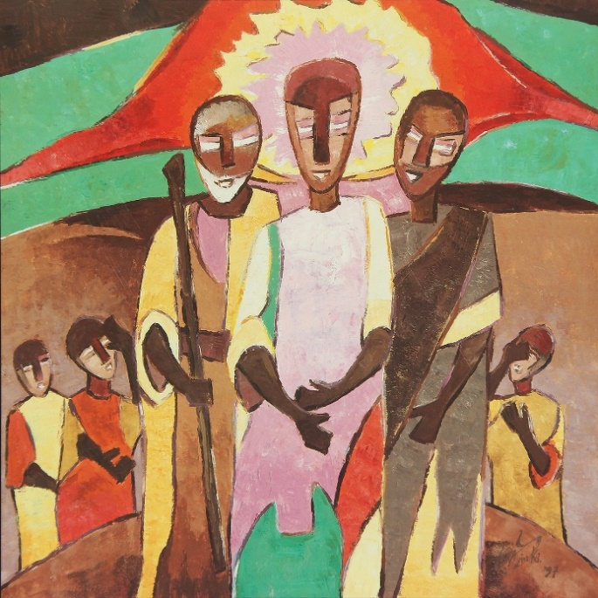
Augustin Kolawole Olayinka (1997)

Minister
Rev Fiona Maxwell

Organist
Mr Alex Ferguson

