The vision of the Church of Scotland is to be a church which seeks to inspire the people of Scotland and beyond with the Good News of Jesus Christ through enthusiastic, worshipping, witnessing, nurturing and serving communities.

Welcome

Reading “How should we view Christmas”.
Maureen Moore

Praise 301 Hark the Herald angels sing
(Advent Candle lit during first verse)

Prayer of Approach and Lord’s Prayer
Jean Johnston

Choir Somewhere in our silent night

Reading “Joseph and Mary”
Janette Steven

Praise 304 O Little town of Bethlehem

Choir Mary did you know/Let all mortal flesh

Reading “Visitors at the manger”
Audrey Gray

Praise 323 The First Noel

Choir “By the Light of a distant star”

Prayer of Thanksgiving and for others
Aileen Sansum

Reading “Good News”
Jess Barry

Praise 320 Joy to the World

Benediction

Choir “Thankful”

Notices

A warm welcome is extended to everyone this morning and especially to any visitors worshipping with us today.

Please take a few minutes to read the screens as there may be information, which was received too late for the printed intimations.

Our minister, the Rev. Fiona Maxwell, can be contacted by telephone on 01563 521762, or by email, FMaxwell@churchofscotland.org.uk

The email address for the Church Administrator is kppcchurchoffice@gmail.com or phone 07394 173977.

If you are watching the service via live stream the digital order of service is available on the church website under the services page.

Reminder If you have a hearing device, please make sure you have put it to the ‘T‘ position to enable it to link up with the church loop system.

Tea/coffee will be served after morning worship, please come down to the hall for a warm cuppa and even warmer chat and fellowship.

The Guild meet on Tuesday 16 December at 2pm. All Welcome.

Wednesday Walkers meet at the Kay Park at 10am at the top car park near the Burns Centre, enjoy a walk round the park and a good chat. All welcome.

Wednesday Café 10am – 12 noon all welcome for a cuppa and chat.

Saturday 20 December 11am – 12noon Carols at the Cross. Sing favourite carols with the Salvation Army in the town centre, then warm up with hot drinks at New Laigh Kirk at noon.

Sunday 21 December Nativity Musical 11am led by our Young Church.

Wednesday 24 December – Christmas Eve 4pm – Refreshments available from 3.15pm in the hall, then we move to the Church for Carols and a Christmas message. All welcome.

Advance Notice
Heartstart are running a CPR Training course on Wednesday 14 January at 7pm. If you are interested in coming to this event, please speak to John Dyet
Advance Notice
The Church are having a Fundraising Quiz Night on Friday 30 January at 7pm, tickets for this event will be on sale in early January at a cost of £8.

Foodbank- Items can still be left at the back of the church in the wicker basket, these items are then taken to the Salvation Army for their foodbank, supplies are required urgently, so please give generously.

New to Kay Park?
If you are new to Kay Park, please feel free to approach the Minister, Rev Fiona on (01563) 521762 or the Session Clerk, Jean Johnston, 07944 891078, for further information about the Church and Membership. If you would like information about giving to the church financially, please contact the Treasurer, Gordon Slater 07768 780051

Stamps If you are one of the few people who still gets letters with stamps we are looking for your stamps. There will be a box in the café area for you to put them, these will then be trimmed and sent away to Embrace the Middle East or Mercy Ships.

Fellowship of Kilmarnock Churches latest newsletter is available at the back of the church, please take one if you wish.

Fiona Kendall – Mission Partner Newsletter is available at the back of the church, please feel free to take one.

The latest edition of Newsbite Winter 2025 is now available at the back of the church, please take one if you don’t get it delivered by an Elder.

The BIG CHRISTMAS CARD is available in the vestibule for anyone wishing to sign it and make a donation to Mediterranean Hope.

Advent Booklets are at the back of the church if you would like to take one.

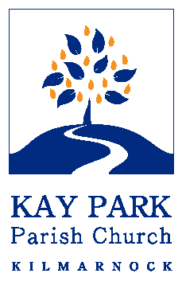
www.kayparkparishchurch.org.uk
(Registered Scottish Charity: SC008154)

14 December 2025
Advent 3

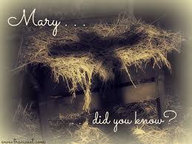

Minister
Rev Fiona Maxwell

Musicians
Alex Ferguson
Grant Donald
Stacey Connell

