The vision of the Church of Scotland is to be a church which seeks to inspire the people of Scotland and beyond with the Good News of Jesus Christ through enthusiastic, worshipping, witnessing, nurturing and serving communities.

Entry of the Bible (we stand as the Bible is brought into church)

Introit

Grace and Call to Worship

Praise Come People of the Risen King

Prayer of Approach and Lord’s Prayer

Praise 425 The Saviour Died but rose again

Bible Reading John chapter 20 v 19 – 31 (pg 1089)
(Shiona Thomson)

Praise 417 Now the green blade riseth

REFLECTION on GOD’s WORD

Music Video “Peace be with you”

Prayers of Thanksgiving and for others

Praise 416 Christ is Alive! Let Christians sing
(Tune: Truro)

Benediction

Notices

A warm welcome is extended to everyone this morning and especially to any visitors worshipping with us today.

Please take a few minutes to read the screens as there may be information, which was received too late for the printed intimations.

Our minister, the Rev. Fiona Maxwell, can be contacted by telephone on 01563 521762, or by email, FMaxwell@churchofscotland.org.uk

The email address for the Church Administrator is kppcchurchoffice@gmail.com or phone 07394 173977.

If you are watching the service via live stream the digital order of service is available on the church website under the services page.

Reminder If you have a hearing device, please make sure you have put it to the ‘T‘ position to enable it to link up with the church loop system.

Tea/coffee will be served after morning worship, please come down to the hall for a warm cuppa and even warmer chat and fellowship.

Wednesday Walkers meet at the Kay Park at 10am at the top car park near the Burns Centre, enjoy a walk round the park and a good chat. All welcome.

Wednesday Café 10am – 12 noon all welcome for a cuppa and chat.

Friendship Club meet on Thursday 16 April at 2pm for their Spring Tea

Fellowship of Kilmarnock Churches Christian Aid Fundraiser is on 17 April at 7.30pm in the Church. Admission is free, donations to Christian Aid. Enjoy the music of The Ayrshire Fiddle Orchestra & friends from Castellar del Vallès, Barcelona,

Hustings Debate at the Howard Centre on Friday 24 April at 7.30 pm. Every candidate standing to be our MSP in the elections on 7 May will be invited to appear on a panel. This is their opportunity to tell you what they stand for and to answer questions which matter to you. At present you may be undecided how to vote, but people fought to win the right to vote and we should use our vote wisely.

Next Praise and Worship Evening: A warm invitation from the band to our next Worship Night here in John Knox on Saturday evening, 25th April. Doors open at 7pm for refreshments, and a 7.30 start. A wonderful opportunity to become more familiar with some of the newer songs, along with time for reflection in a relaxed atmosphere, a cuppa, chat, and band-led worship. ALL WELCOME - do come and join with us as we worship!

Foodbank- Items can still be left at the back of the church in the wicker basket, these items are then taken to the Salvation Army for their foodbank, supplies are required urgently, so please give generously.

New to Kay Park?
If you are new to Kay Park, please feel free to approach the Minister, Rev Fiona on (01563) 521762 or the Session Clerk, Jean Johnston, 07944 891078, for further information about the Church and Membership. If you would like information about giving to the church financially, please contact the Treasurer, Gordon Slater 07768 780051

Stamps If you are one of the few people who still gets letters with stamps we are looking for your stamps. There will be a box in the café area for you to put them, these will then be trimmed and sent away to Embrace the Middle East or Mercy Ships.

Hospital Volunteers
The League of Friends requires more volunteers as some volunteers are unable to work due to health conditions. Volunteers are needed urgently to work in the tea bar and shop at Crosshouse Hospital on Tuesdays every four weeks, with a choice of shifts from 9.30am to 12noon, 12noon to 2.00pm or 2.00pm to 4.00pm.
If you would like to join the team, please contact Helen Colman, T: 01563 524259, E: helenmcolman@gmail.com.

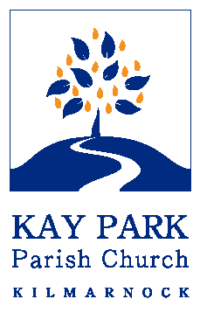
www.kayparkparishchurch.org.uk
(Registered Scottish Charity: SC008154

Easter 2
Sunday 12 April 2026

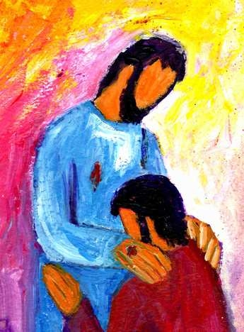

Minister
Rev Fiona Maxwell

Lead Musician
Alex Ferguson

