The vision of the Church of Scotland is to be a church which seeks to inspire the people of Scotland and beyond with the Good News of Jesus Christ through enthusiastic, worshipping, witnessing, nurturing and serving communities.

Entry of the Bible
(we stand as the Bible is brought into church)

Grace & Call to Worship
Introit

Praise 456 Christ is the World’s true light (Tune: Nun Danket)

Prayer of Approach and Lord’s Prayer

Chat to all

Praise 481 Jesus is the name we honour

Bible reading Mark chapter 9 v 2-9 (pg 1012)
(Tracey Neilson)
Anthem
REFLECTION ON GOD’S WORD

Praise MP 366 Jesus is King

Prayers of Thanksgiving and for others

Praise 355 You, Lord, are both Lamb and Shepherd
(Tune: Regent Square)

Benediction

Notices

A warm welcome is extended to everyone this morning and especially to any visitors worshipping with us today.

Please take a few minutes to read the screens as there may be information, which was received too late for the printed intimations.

Our minister, the Rev. Fiona Maxwell, can be contacted by telephone on 01563 521762, by mobile on 07507 312123 or by email, FMaxwell@churchofscotland.org.uk

The email address for the Church Administrator is kppcchurchoffice@gmail.com or phone 07394 173977. Please note the new email address for the church administrator.

If you are watching the service via live stream the digital order of service is available on the church website under the services page.

There is now creche and young church facilities in the side chapel, if you have children with you, please use this room as and when you need to.

Tea/coffee will be served after morning worship, please come down to the hall for a warm cuppa and even warmer chat and fellowship.

The Guild meet on Tuesday 13 February at 2pm for an afternoon with True Colours a Ukelele Band, All Welcome.

Wednesday Walkers meet at the Kay Park at 10am at the top car park near the Burns Centre, enjoy a walk round the park and a good chat and then have coffee/tea in the church café. All welcome.

Wednesday café is open every Wednesday morning from 10am – 12 noon. Please tell your friends and neighbours and come and enjoy the company and chat.
Claire from Vibrant Communities will be at the café from 10.30 to 11.30 providing an opportunity to have a health check carried out.

Ash Wednesday Service, 14 February, 7pm in the Church

Founders Day Parade, Sunday 18 February, the young people and families involved with the Scouts will be with us.

KIRK SESSION will meet on Wednesday, 21 February at 7pm.

Loudoun Musical Society are having a concert in the Church on Friday 23 February at 7.30, tickets are £8, please speak to Vanessa or email her today if you would like a ticket for the concert.

PAUSE for HOPE Service on Sunday, 25 February, 3pm Salvation Army. This gathering will focus on those who have been affected by a cancer and its impact.

Foodbank- Items can still be left at the back of the church in the wicker basket, these items are then taken to the Salvation Army for their foodbank, supplies are required urgently, so please give generously.

New to Kay Park?
If you are new to Kay Park, please feel free to approach the Minister, Rev Fiona on (01536) 521762 or the Session Clerk, Janette Steven, (01563) 401209, for further information about the Church and Membership. If you would like information about giving to the church financially, please contact the Treasurer, Alex Steven on 01563 401209

www.kayparkparishchurch.org.uk
(Registered Scottish Charity: SC008154)

Sunday 11 February 2024
Transfiguration
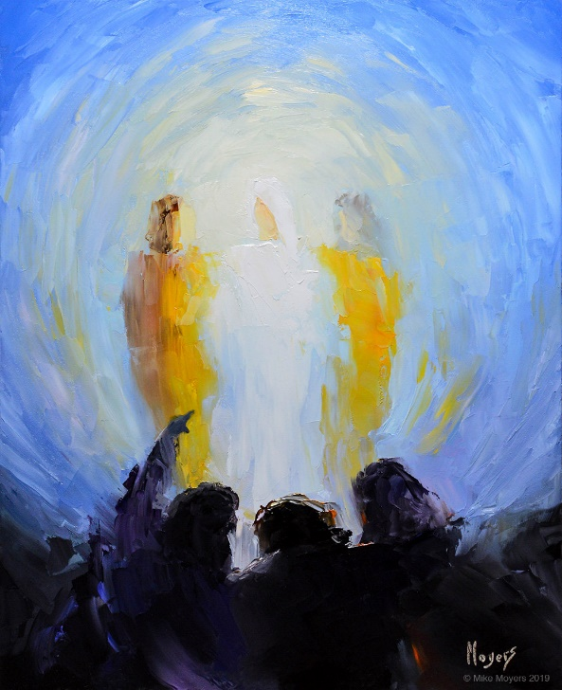
Minister
Rev. Fiona Maxwell

Organist
Mr Alex Ferguson

