The vision of the Church of Scotland is to be a church which seeks to inspire the people of Scotland and beyond with the Good News of Jesus Christ through enthusiastic, worshipping, witnessing, nurturing and serving communities.

Grace

Praise 192 All my hope on God is founded

Prayer of Approach and The Lord’s Prayer

Act of Remembrance

Praise 528 Make me a channel of your peace
Scripture Ephesians chapter 2 v 13- 18 (p 1174) (Reader: Fiona McBride)
Anthem

Reflection on God’s Word

Praise 706 For the healing of the nations
(Tune: Regent Square)

Offering

Prayer of Thanksgiving and for others

Praise 707 Healing River of the Spirit
(Tune: Blaenwern)

Benediction

INTIMATIONS

A warm welcome is extended to everyone this morning and especially to any visitors worshipping with us today.

Young Church will leave after the second hymn to enjoy their activities in the hall downstairs, whilst the crèche for under 3’s meets in the crèche room.

Tea and coffee will be available downstairs at the close of the service and we hope as many people as possible will stay and enjoy the chat.

Please take a few minutes to read the screens as there may be information, which was received too late for the printed intimations.

Our minister, the Rev. Fiona Maxwell, can be contacted by telephone on 01563 521762, by mobile on 07507312123 or by email, FMaxwell@churchofscotland.org.uk

The email address for the Church Administrator is chrchdmnstr@outlook.com. Vanessa can be found in the office on Wednesday and Friday from 9.00 until 12.00 and on Thursday afternoon from 1.00pm until 4.00pm.

A big THANK YOU to everyone who filled a shoebox this year. 77 boxes were collected yesterday and are now travelling across Europe in time for Christmas.

Jess Barry is in the process of putting together the new list for Scripture Readers for 2020. If you no longer want to be on the list, or if you would like to be added to the list please speak to Jess Barry as soon as possible. Thank you

Kirk Session meets on Tuesday 12th November for an important meeting regarding the Church of Scotland Path of Renewal. A good attendance is required to inform and discuss this new venture.

The Friendship Club meets on Thursday 14th November for an afternoon of our Favourite Hymns led by Isabel Aitken. A warm welcome is extended to everyone.

Exploring the God Question – Science, God and the Search for Truth continues in the side chapel at 7.30 – 9.00 on Thursday. Don’t worry if you have missed any just come to what you can.

Messy Church meeting Thursday 14th November at 7.30pm in the vestibule for a quick update.

Pilgrimage to the Holy Land February 2021
Next Sunday, 17 November there will be a meeting immediately after morning worship for all those interested in the Pilgrimage to the Holy Land, February 2021. We will meet in the side chapel area.

Fellowship of Kilmarnock Churches meets on 24th November at 2.30pm in the Salvation Army to look at the story of Mary. All welcome.

Invitation to Holy Trinity Church to an exhibition in conjunction with the Scottish Interfaith Group on Domestic Abuse to mark ’16 DAYS OF ACTIVISM AGAINST GENDER BASED VIOLENCE’. The exhibition is entitled ‘THE SOULS OF OUR SHOES’ expressed by visual effects; words and music and the effects of domestic abuse on men, women and children. Tuesday 26th November 2pm -6pm and 7pm -9pm and Wednesday 27th November 12 – 4pm.

Messy Church is on Saturday 30th November from 2pm – 4pm in the Church Halls. This is for babies up to P7. Come along for an afternoon of crafts, music, story, food and friendship.

The Church Christmas Lunch is on the 15th December after morning worship, tickets will be on sale today and for the rest of November from the Social Committee and in the halls after morning worship. Save the date.

------------------------------------------------------------------------------

Pastoral Calls
Please let the Minister know today of any member you feel would benefit from a visit – those in hospital, ill at home, needing some extra pastoral support for whatever reason or tell of those who would like to talk to about any other matter. Please ask the permission of the person(s) before you pass their details on.

Please write their details down below, tear the page off and give it to an office-bearer today. Thanks.

Name...............................................................Phone No...........................................

Address/Hospital and Ward No.............................................................................

Brief description of the situation............................................................................

........................................................................................................................................


www.kayparkparishchurch.org.uk
(Registered Scottish Charity: SC008154)

10 November 2019
Remembrance Sunday

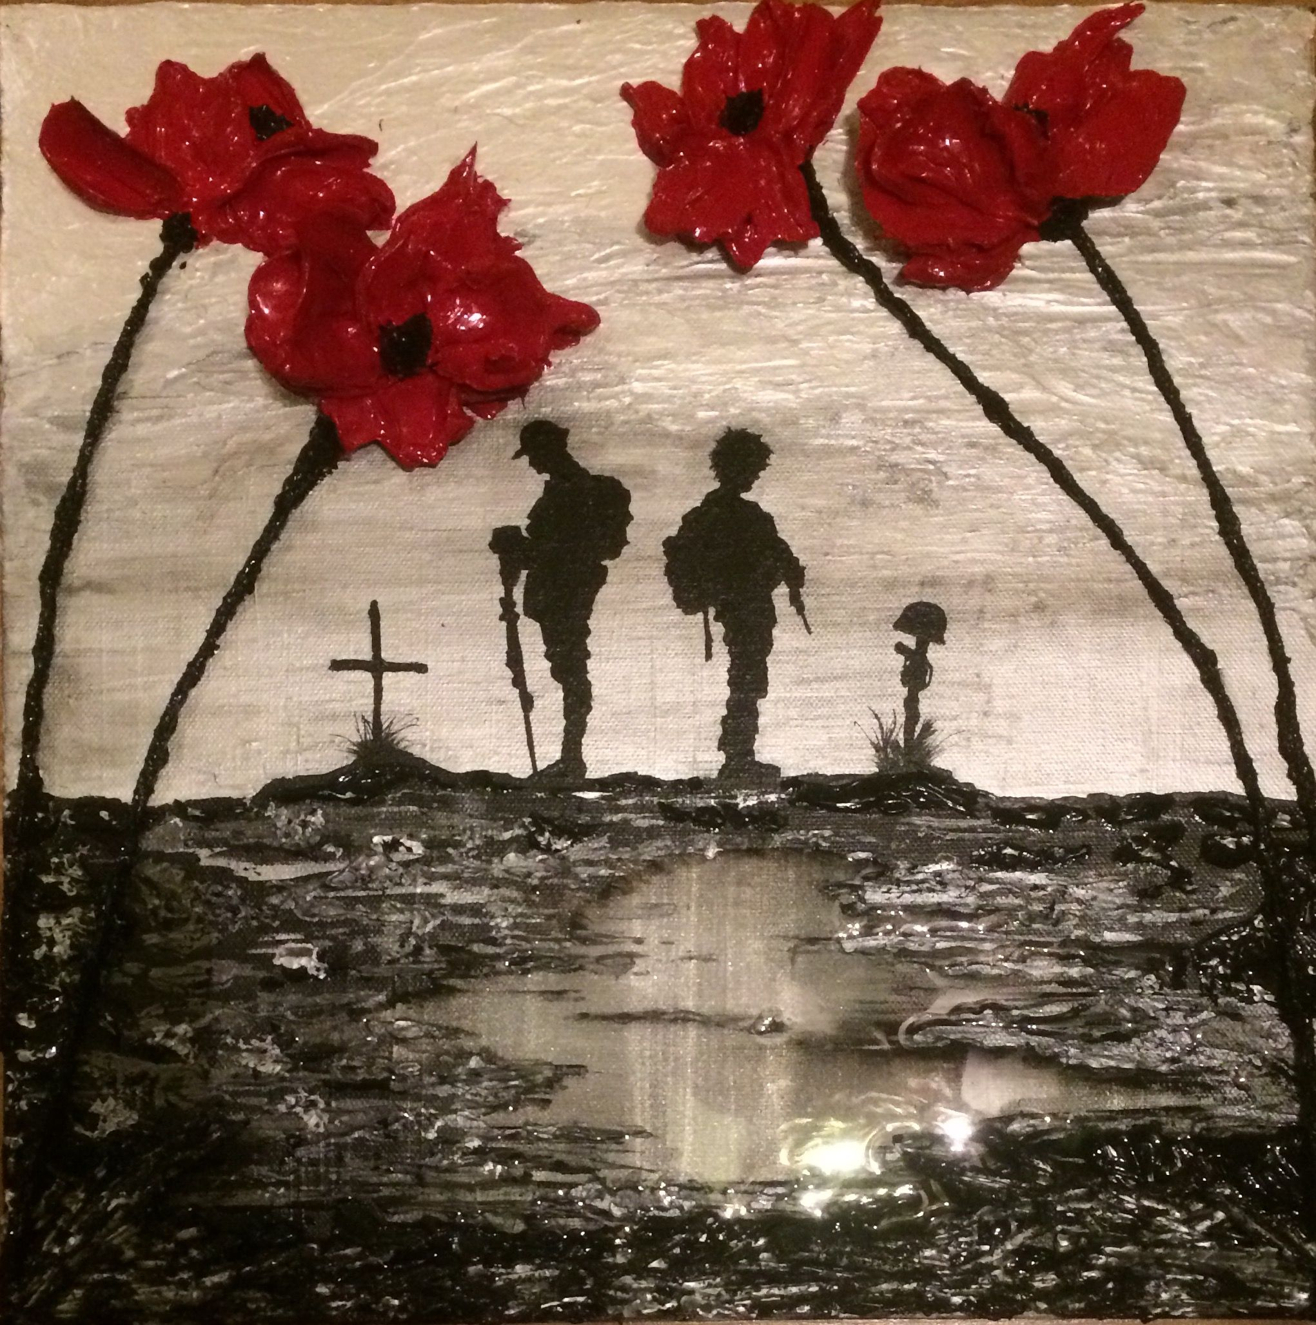

Organist
Mr Alex Ferguson

Minister
Rev. Fiona Maxwell BA BD

