The vision of the Church of Scotland is to be a church which seeks to inspire the people of Scotland and beyond with the Good News of Jesus Christ through enthusiastic, worshipping, witnessing, nurturing and serving communities.

Entry of the Bible
(we stand as the Bible is brought into church)

Welcome - Grace & Call to Worship

Praise 152 Praise the Lord his glories show

Prayer of Approach and the Lord’s Prayer

CHAT for ALL

Praise Living Stones

Bible Reading 1 Peter chapter 2 v 1-11 (pg 1218)
(Elizabeth Templeton)

Praise 619 Spirit of the Living God

REFLECTION ON GOD’S WORD

Praise 620 Spirit of the Living God (v2)

Prayers of Thanksgiving and for Others

Praise 642 Ye, that know the Lord is Gracious

Benediction

Notices
A warm welcome is extended to everyone this morning and especially to any visitors worshipping with us today.

Please take a few minutes to read the screens as there may be information, which was received too late for the printed intimations.

The email address for the Church Administrator is kppcchurchoffice@gmail.com or phone 07394 173977. Please note the new email address for the church administrator.

If you are watching the service via live stream the digital order of service is available on the church website under the services page.

There is now creche and young church facilities in the side chapel, if you have children with you, please use this room as and when you need to.

Tea/coffee will be served after morning worship, please come down to the hall for a warm cuppa and even warmer chat and fellowship.

Jean Herbert will be taking orders for the Crossreach Christmas cards today and on the 8th October, money must be received by the 8th October.

Scalliwags meet Monday at 9.30am – 11am. The group is for all children under 3 and should be accompanied by an adult.

Brownies & Guides 17th Kilmarnock Brownies and 6th Kilmarnock Guides will meet in the church halls on Monday at 6pm and 7.30pm.

Wednesday Walkers meet at the Kay Park at 10am at the top car park near the Burns Centre, enjoy a walk round the park and a good chat and then have coffee/tea in the church café. All welcome.

Wednesday café is open every Wednesday morning from 10am – 12 noon. Please tell your friends and neighbours and come and enjoy the company and chat.

Strollers' walk will be on Thursday 5th October. Assemble for 10am at Prestwick shorefront car park adjacent to Cafe Mancini at the foot of Links Road (KA9 1QG).

Friendship Club meet back on Thursday 5 October at 2pm, this meeting will be led by Shiona Thomson and guest speaker Our Minister, Rev Fiona Maxwell, new and old members welcome.

From Scotland to Taiwan exhibition is from 8 October to 31 October this year, opening ceremony will take place at 12:30 on 8 October combined with the Sunday service of the church. The exhibition space is the St. George's Tron Church of Scotland, Glasgow. Exhibition open from 10.30 – 16.30 Mon – Sat.

Foodbank- Items can still be left at the back of the church in the wicker basket, these items are then taken to the Salvation Army for their foodbank, supplies are required urgently, so please give generously.

New to Kay Park?
If you are new to Kay Park, please feel free to approach the Minister, Rev Fiona on (01536) 521762 or the Session Clerk, Janette Steven, (01563) 401209, for further information about the Church and Membership. If you would like information about giving to the church financially, please contact the Treasurer, Alex Steven on 01563 401209

Sunday 8 October - Harvest Thanksgiving
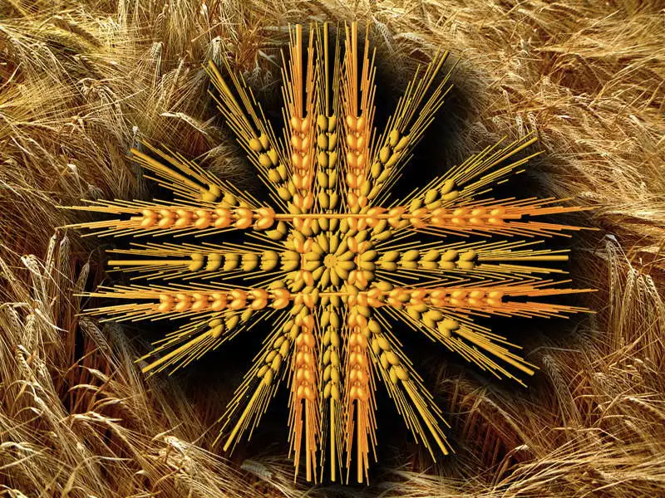

Everyone is invited to bring along a donation for the Salvation Army Foodbank. This can be dried or canned food, toiletries, dental hygiene or sanitary productions. In particular the Salvation Army are requesting meat dishes i.e tinned meat/stewing steak, hotdogs, meatballs etc.

We will all worship together as a church family and think about being SEEDS for CHANGE.

(NOTE: if you already contribute to another source just keep doing so please)

www.kayparkparishchurch.org.uk
(Registered Scottish Charity: SC008154)

Sunday 1 October 2023
18th after Pentecost

Minister
Rev. Fiona Maxwell

Organist
Mr Alex Ferguson

